**Machine Learning Case Study: Customer Churn Prediction**

In business, it is very important for a company to keep retain their existing customers. However, it is also important to acquire new customers to make more profits.

Churn is a metric that shows customers who stop doing business with the company or a particular service, also known as churn. By using this metrics, most of businesses relook the reasons or factors that affect the churn of people and make strategies to tackle those problems and factors.

If we are aware about the reasons in advance about the churn, in that case we can easily take proper actions to stop this happening of an event. Usually, the major reason behind the churn is poor services, high prices, no offers or better availability of plans in the market.

This creates a need to build a model which can depict the customer attrition. If a company were capable to identify which customer will leave then by giving lucrative offers their churn could be stopped. Here, data act as a fuel of learning or understanding patterns of customers that are most likely to be churn.

In this article, I am going to use a IBM Sample Data Sets. The dataset contains a total record of 7,043 customers and 21 attributes. Out of the entries, 5,174 are active customers and 1,869 are churned, which demonstrates that the dataset is highly unbalanced. The target variable for this assessment is going to be the feature Churn.

Here, our aim is to build a machine learning model capable to identify whether the customer will churn or not based on the customer’s data available. I will use different libraries in jupyter notebook such as Pandas, Numpy, Scikit-Learn and Matplotlib libraries for the implementation.

To accomplish that, I will go through the below steps:

* Step 1: Problem Statement
* Step 2: Data Collection
* Step 3: Exploratory Data Analysis (EDA)
* Step 4: Feature Engineering
* Step 5: Train/Test Split, Model Evaluation Metrics Definition
* Step 6: Hyperparameter Tuning ,Model Selection, Training, Prediction and Assessment

**Problem Statement**

Customer churn is when a company’s customers stop doing business with that company. Businesses are very keen on measuring churn because keeping an existing customer is far less expensive than acquiring a new customer. New business involves working leads through a sales funnel, using marketing and sales budgets to gain additional customers. Existing customers will often have a higher volume of service consumption and can generate additional customer referrals.

Customer retention can be achieved with good customer service and products. But the most effective way for a company to prevent attrition of customers is to truly know them. The vast volumes of data collected about customers can be used to build churn prediction models. Knowing who is most likely to defect means that a company can prioritise focused marketing efforts on that subset of their customer base.

Preventing customer churn is critically important to the telecommunications sector, as the barriers to entry for switching services are so low.

Here, we need to build a customer churn model that depicts whether the existing customer will churn or not.

**Data Collection**

We are using some basic libraries that are needed throughout the case which includes Pandas and Numpy for data handling and processing as well as Matplotlib and Seaborn for visualization. Here, the given data set (.csv format) is downloaded to a local folder, read into the Jupyter notebook and stored in a Pandas DataFrame.

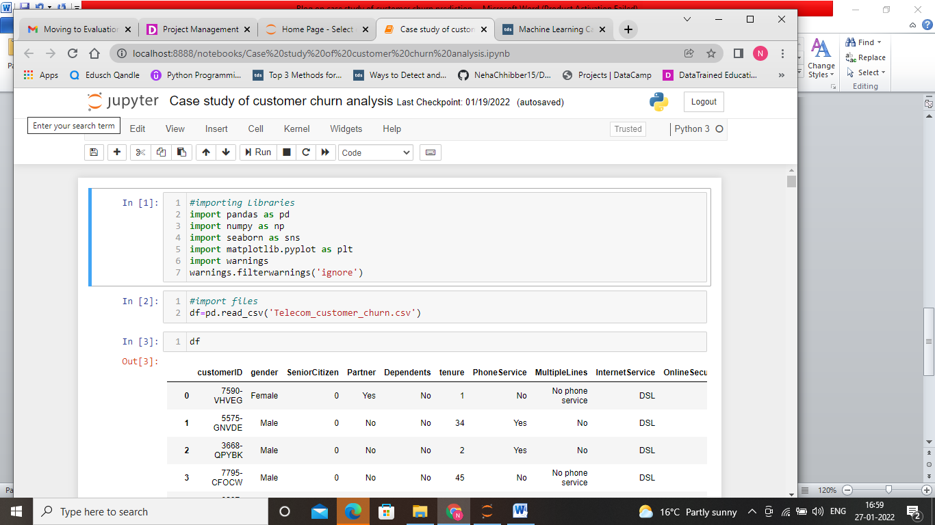

# Exploratory Data Analysis

After collecting and reading the file in Jupyter notebook, several steps are carried out to explore the data. The main aim of this step is to get an understanding of the data set and conduct various steps to get insight from the data such as pre-processing, cleaning, identify patterns and inconsistencies in the data (i.e. skewness, outliers, missing values) and build and validate hypotheses.

# Understanding

In the first part of EDA, we have to find the shape of the given dataset, columns names and data types. The goals of this step are to get a general understanding for the data set, check domain knowledge and get first ideas on topics to investigate. In this step some standard Pandas functions are used:

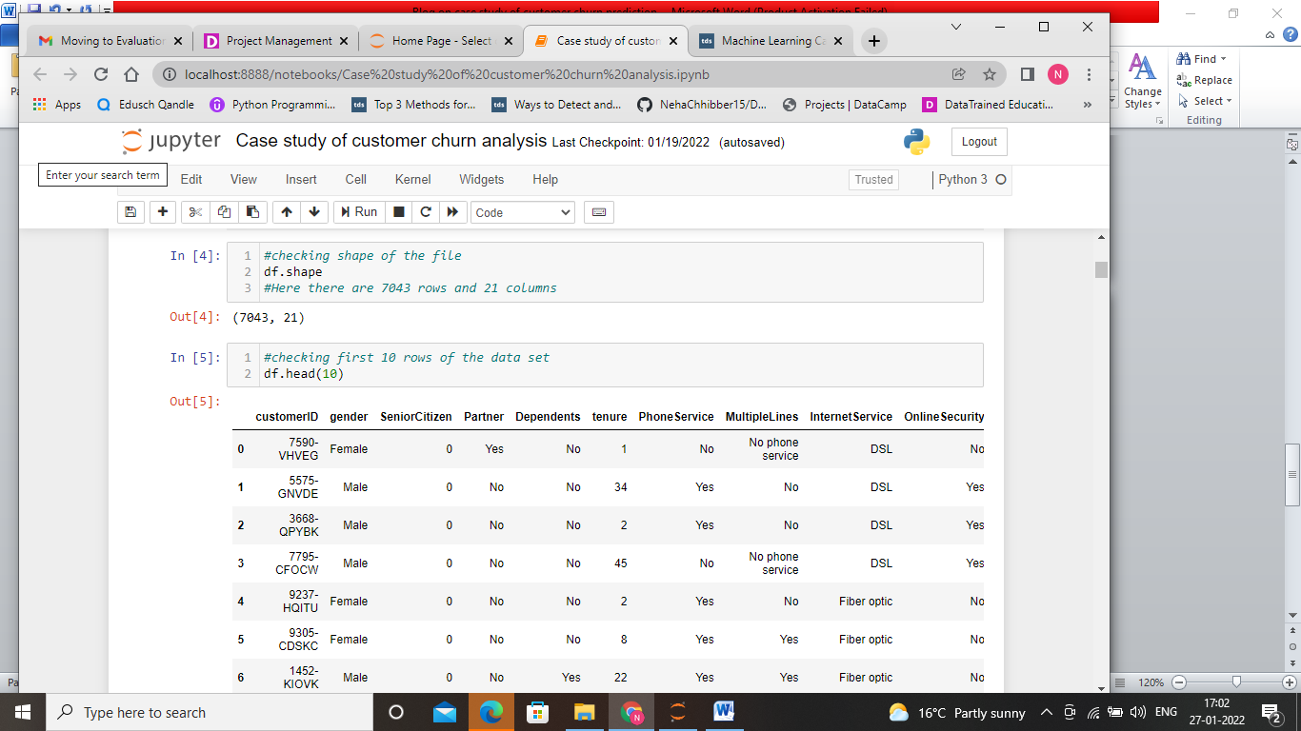

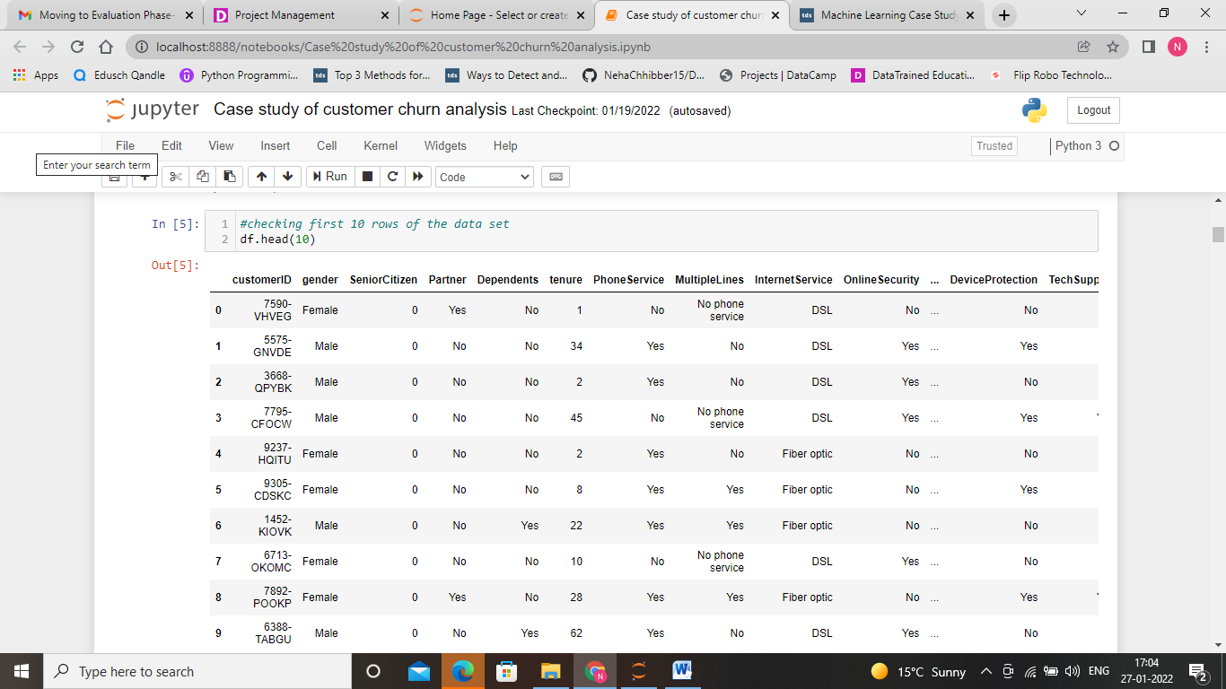

Here, we are checking the first 10 rows of the dataset. This makes us to understand what type of data is present under each column.

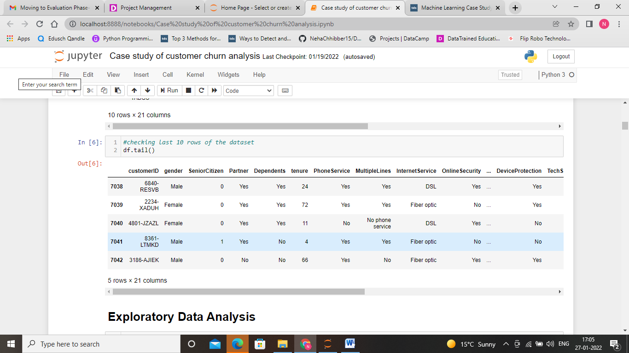

Here, we are checking the last 10 rows of the dataset for better understanding of the data.

Now, let us explore what are the names of the columns in the given dataset.

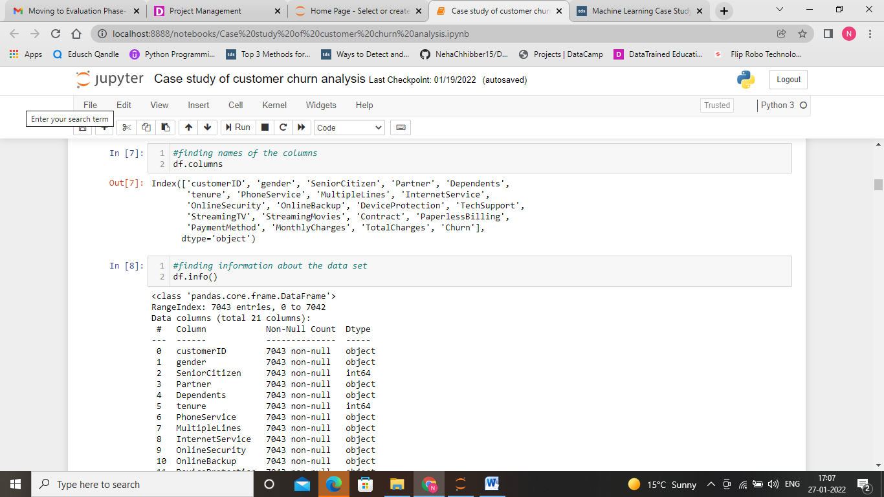

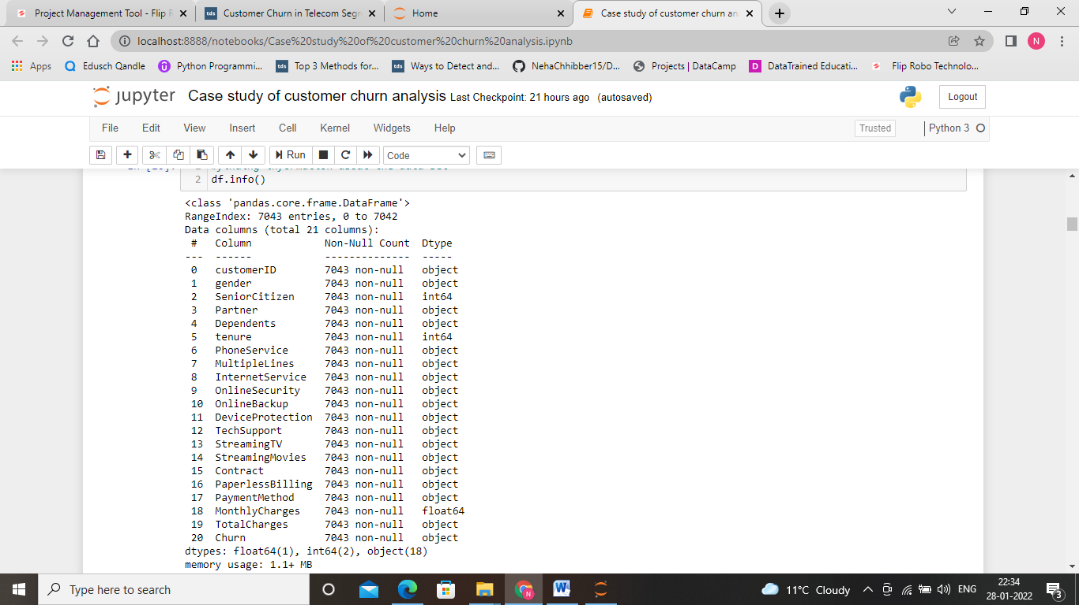

To get more information about each column, we have used df.info

Here, the data type of the columns are object, integer, float.

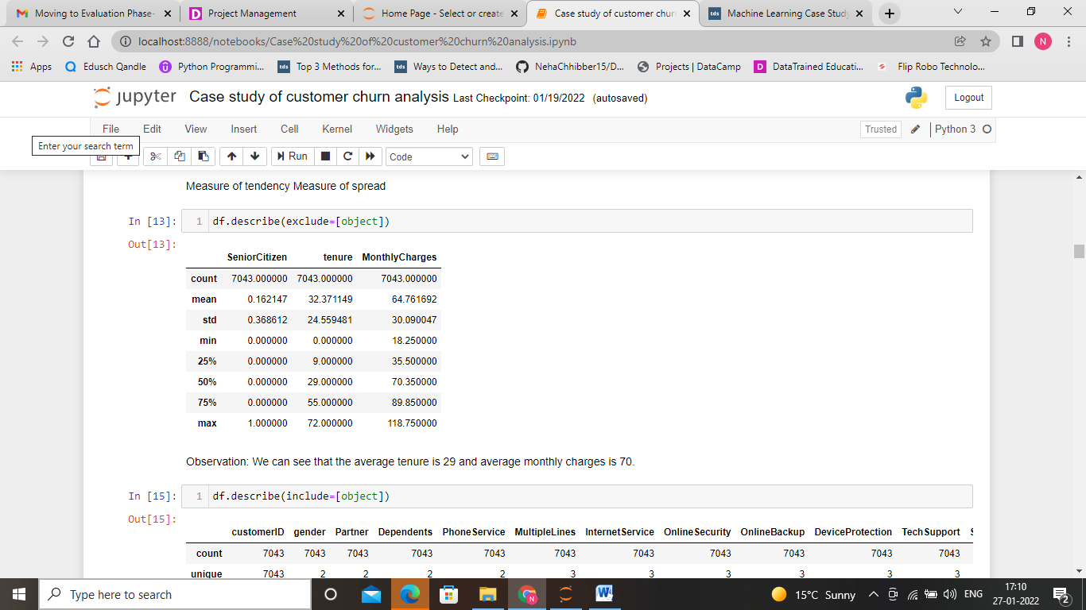

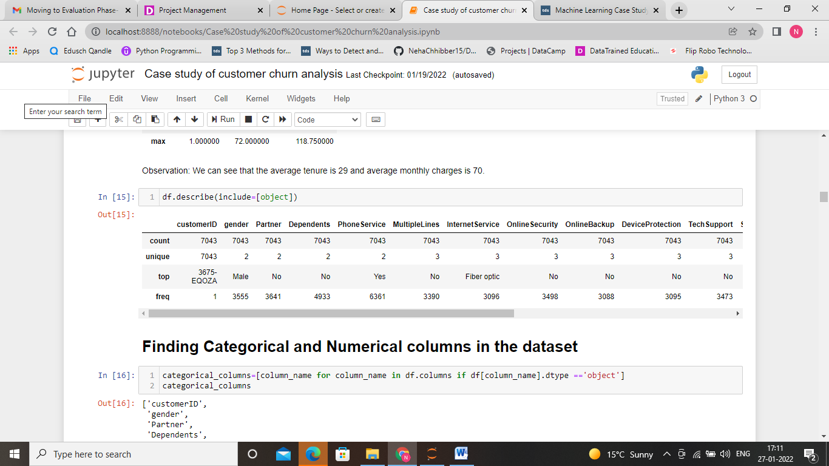

Let us segregate categorical and numerical columns in the given dataset.

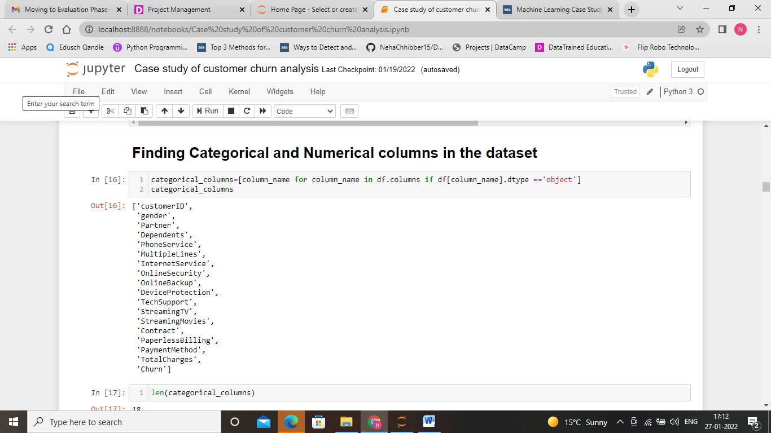

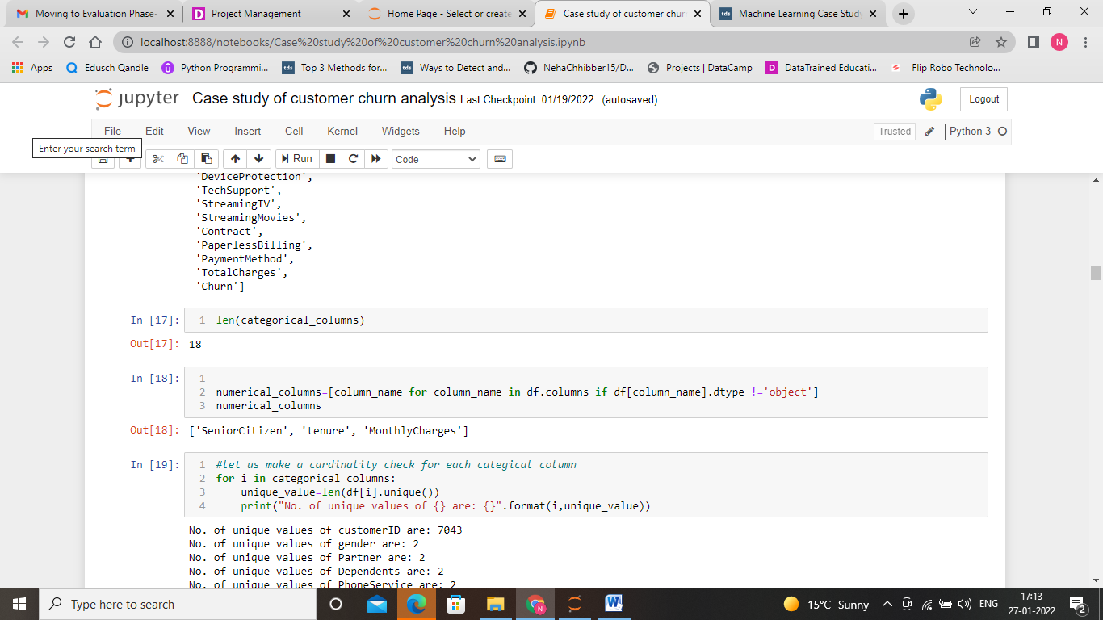

In the given data set, there are 18 categorical and 3 numerical columns present.

The unique values for every feature are printed to the console to get a deeper understanding about the feature values.

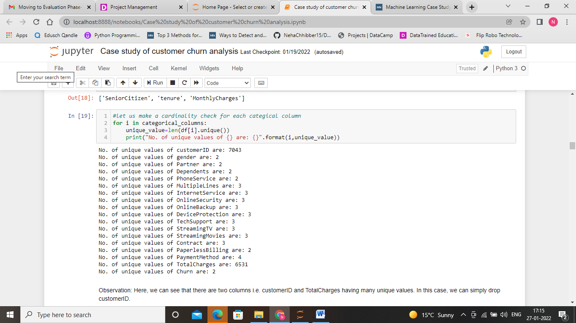

We have many unique values in the customer ID column. So, we can simply drop that column.

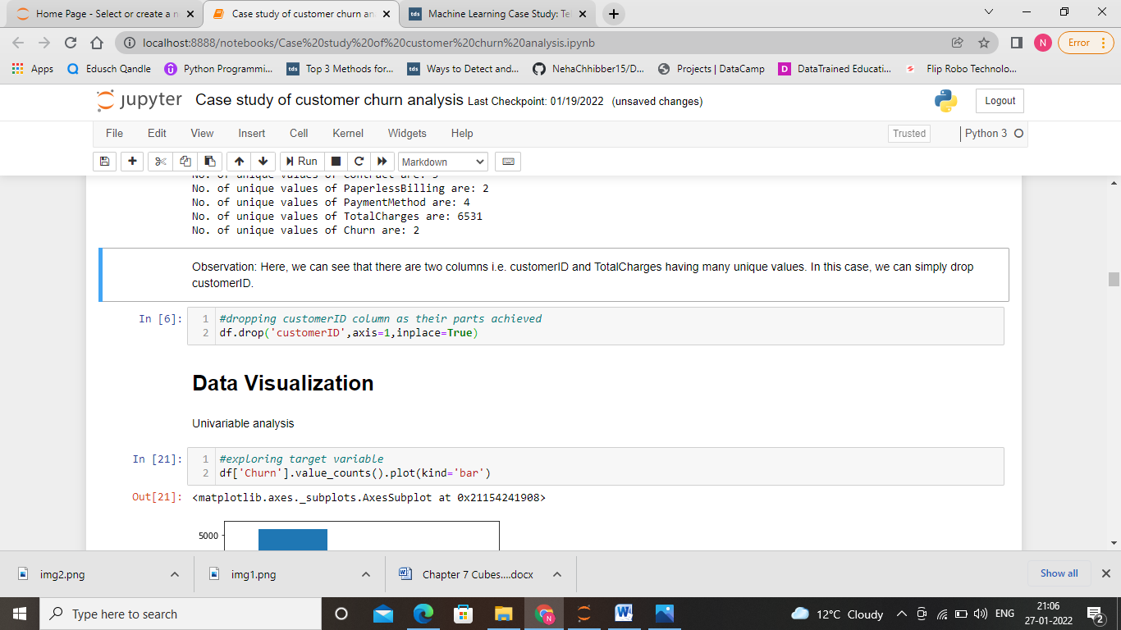

**Meaning of Features**

By inspecting the columns and their unique values, a general understanding about the features can be build. The features can be grouped together into different groups for better understanding.

**Target Variable**

Churn — Whether the customer churned or not (Yes or No)

**Customer services**

* PhoneService — Whether the customer has a phone service (Yes, No)
* MultipleLines — Whether the customer has multiple lines (Yes, No, No phone service)
* InternetService — Customer’s internet service provider (DSL, Fiber optic, No)
* OnlineSecurity — Whether the customer has online security (Yes, No, No internet service)
* OnlineBackup — Whether the customer has online backup (Yes, No, No internet service)
* DeviceProtection — Whether the customer has device protection (Yes, No, No internet service)
* TechSupport — Whether the customer has tech support (Yes, No, No internet service)
* StreamingTV — Whether the customer has streaming TV (Yes, No, No internet service)
* StreamingMovies — Whether the customer has streaming movies (Yes, No, No internet service)

**Account information**

Tenure — Number of months the customer has stayed with the company

* Contract — The contract term of the customer (Month-to-month, One year, Two year)
* PaperlessBilling — Whether the customer has paperless billing (Yes, No)
* PaymentMethod — The customer’s payment method (Electronic check, Mailed check, Bank transfer (automatic), Credit card (automatic))
* MonthlyCharges — The amount charged to the customer monthly
* TotalCharges — The total amount charged to the customer

**Customers demographic info**

* customerID — Customer ID
* Gender — Whether the customer is a male or a female
* SeniorCitizen — Whether the customer is a senior citizen or not (1, 0)
* Partner — Whether the customer has a partner or not (Yes, No)
* Dependents — Whether the customer has dependents or not (Yes, No)

# Data Preprocessing for EDA

# First, let us find whether is any null value present in the given data set or not.

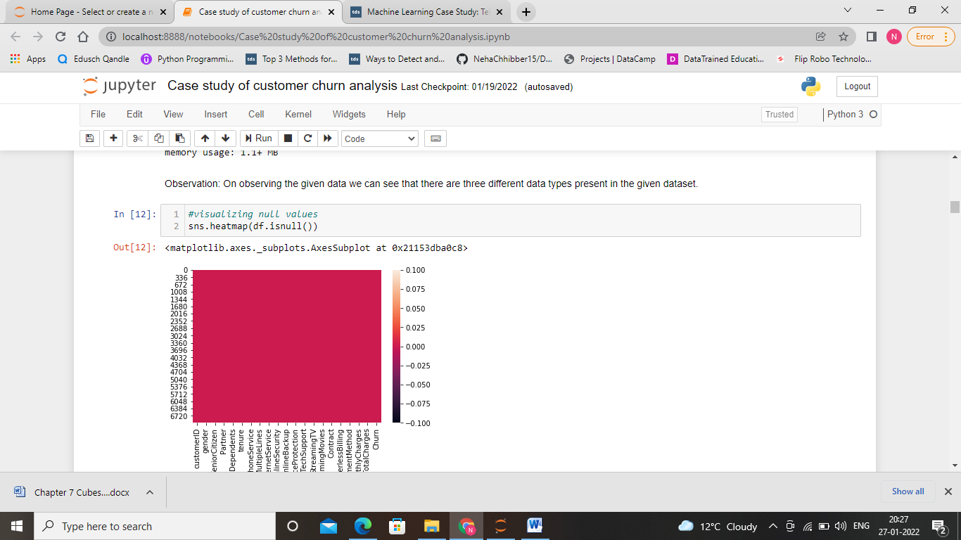

We can see that there is no null values present in the given dataset.

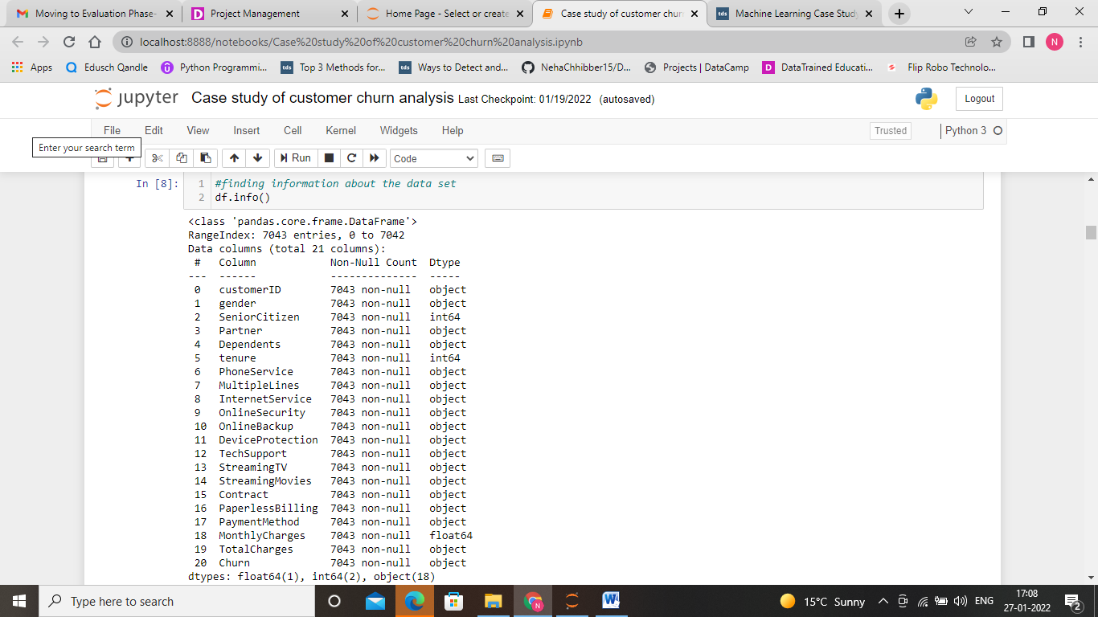

**Data Visualization**

Let us visualize the data by using univariate analysis and Bivariate analysis.

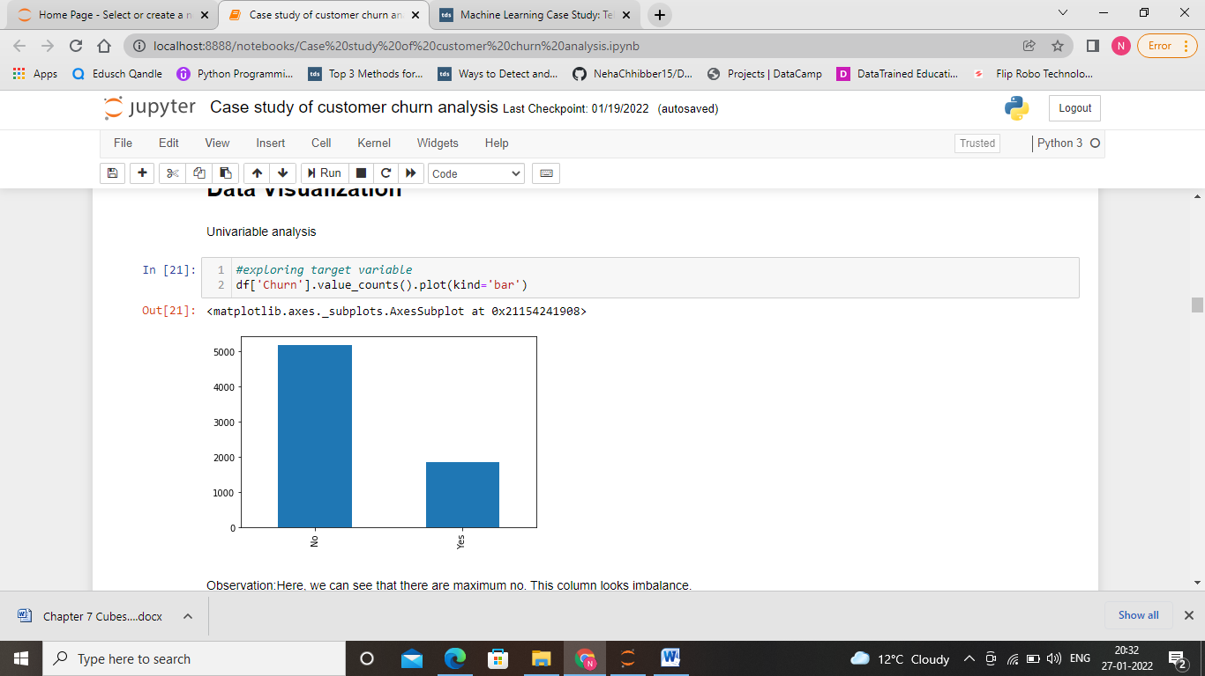

This graph shows that the data between churners and non-churners are highly imbalanced.

Now, let us visualize each feature one by one to build understanding about each feature.

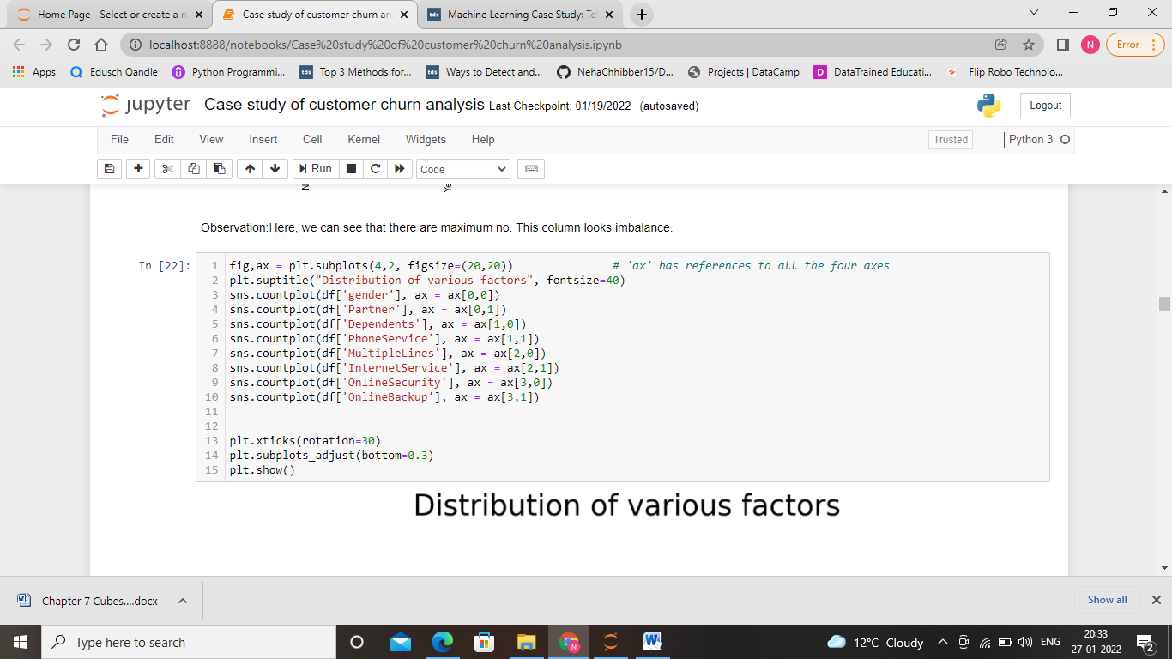

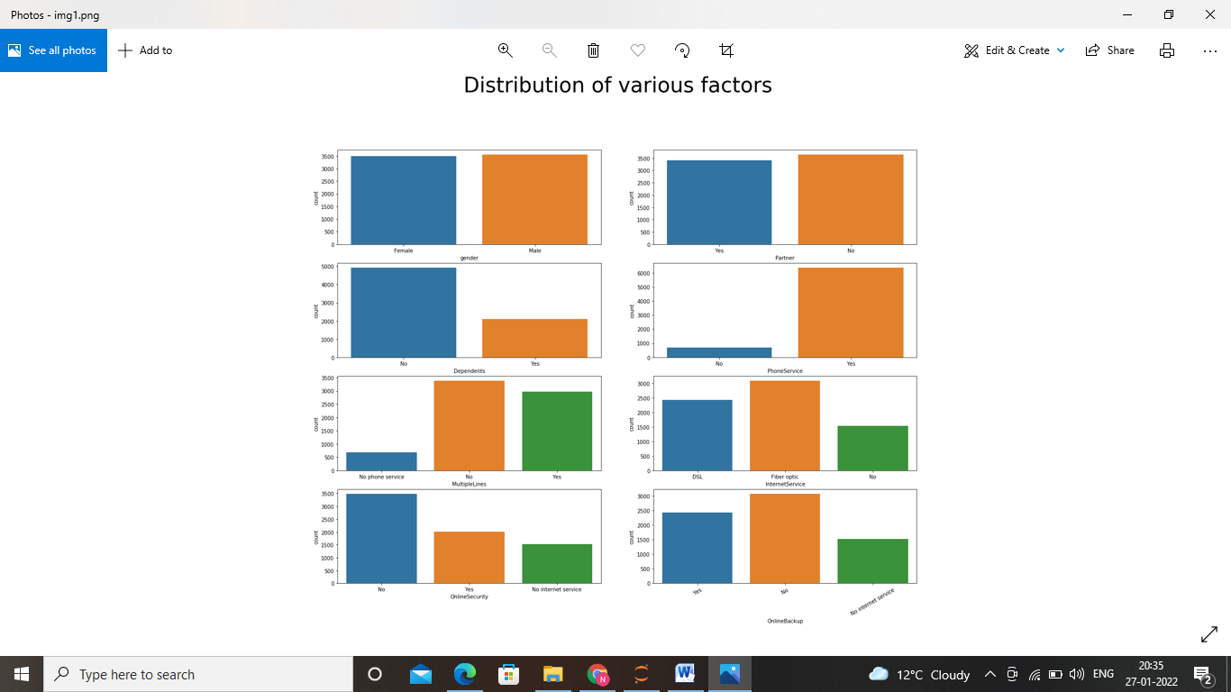

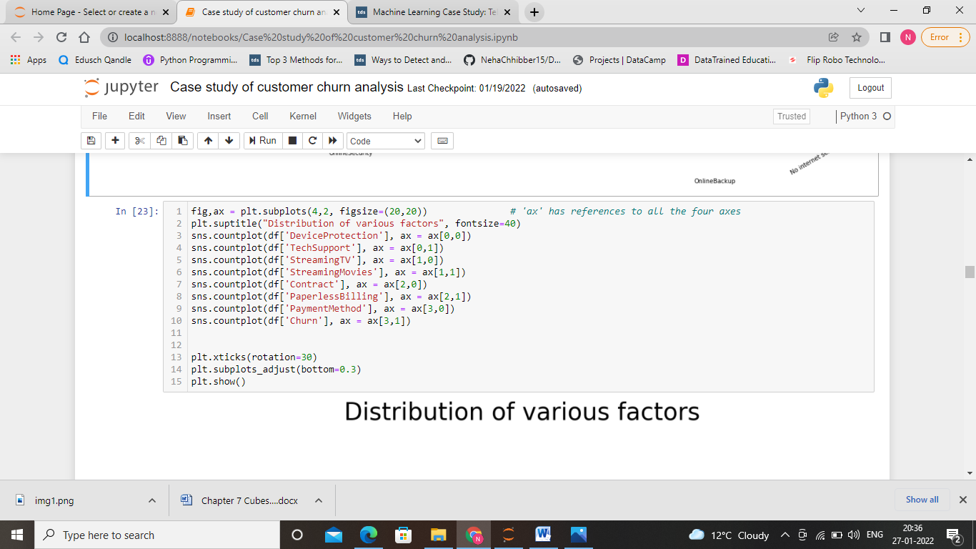

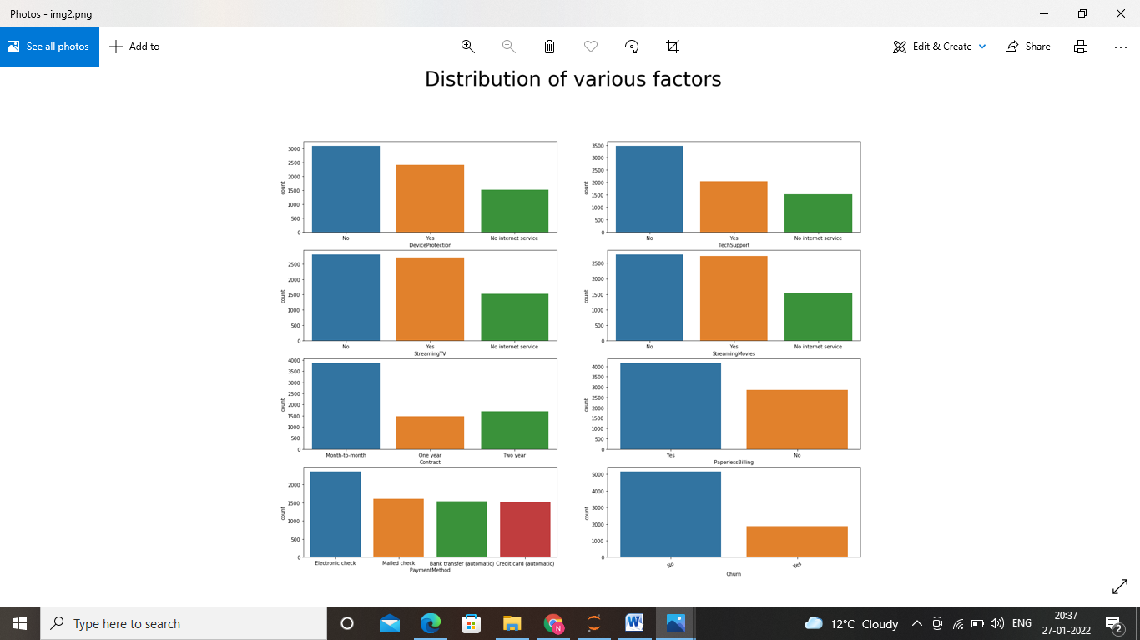

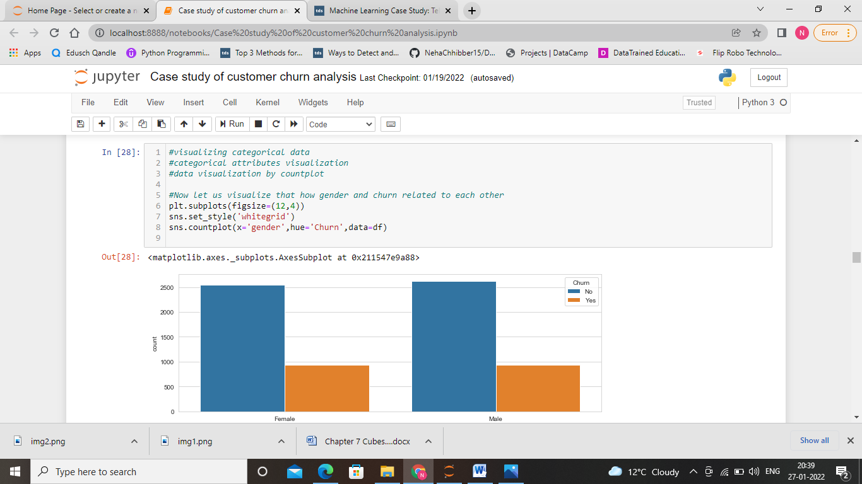

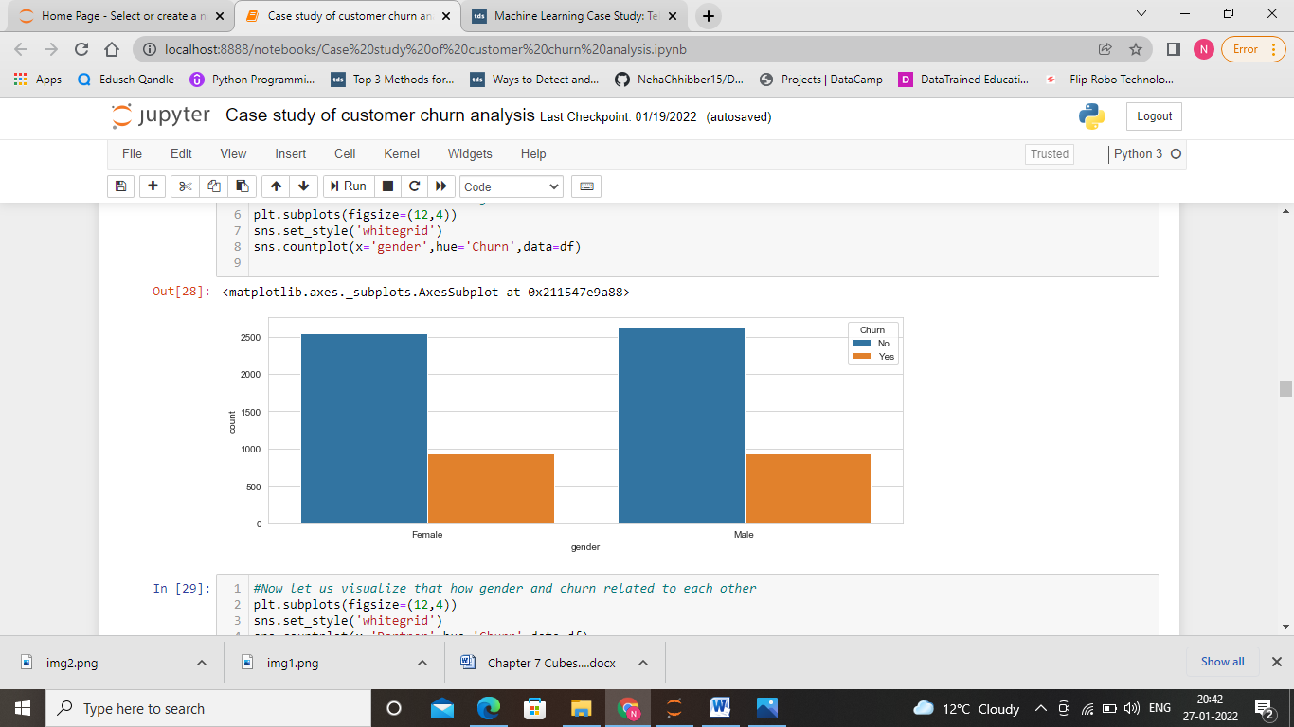

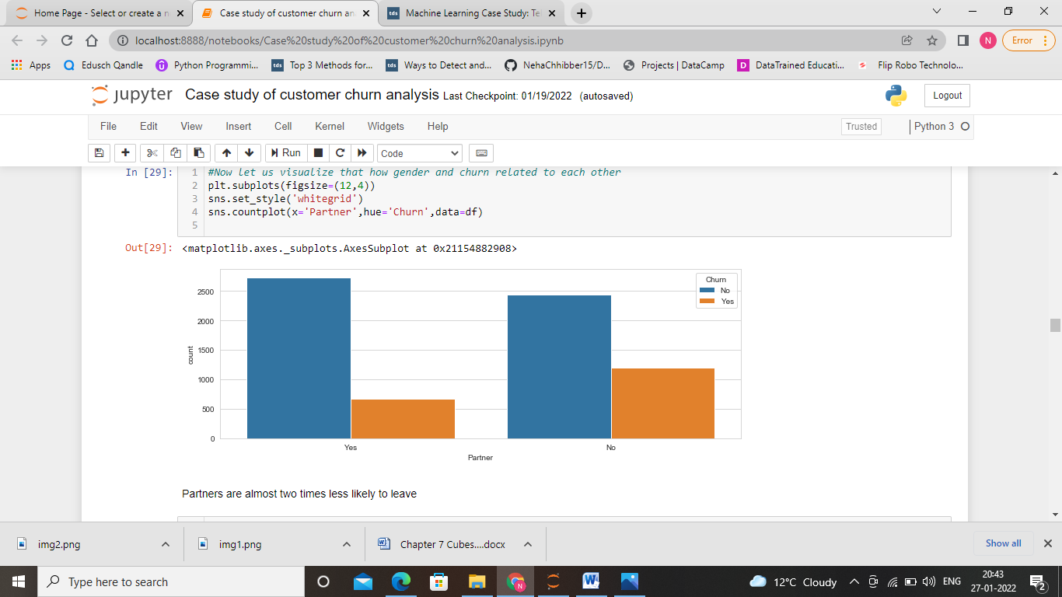

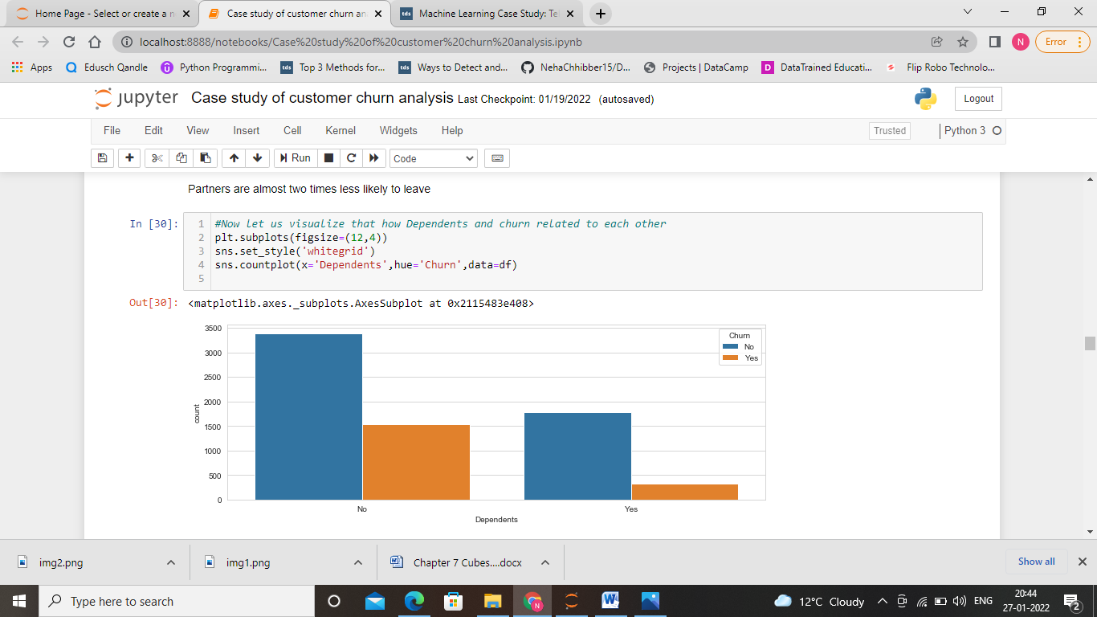

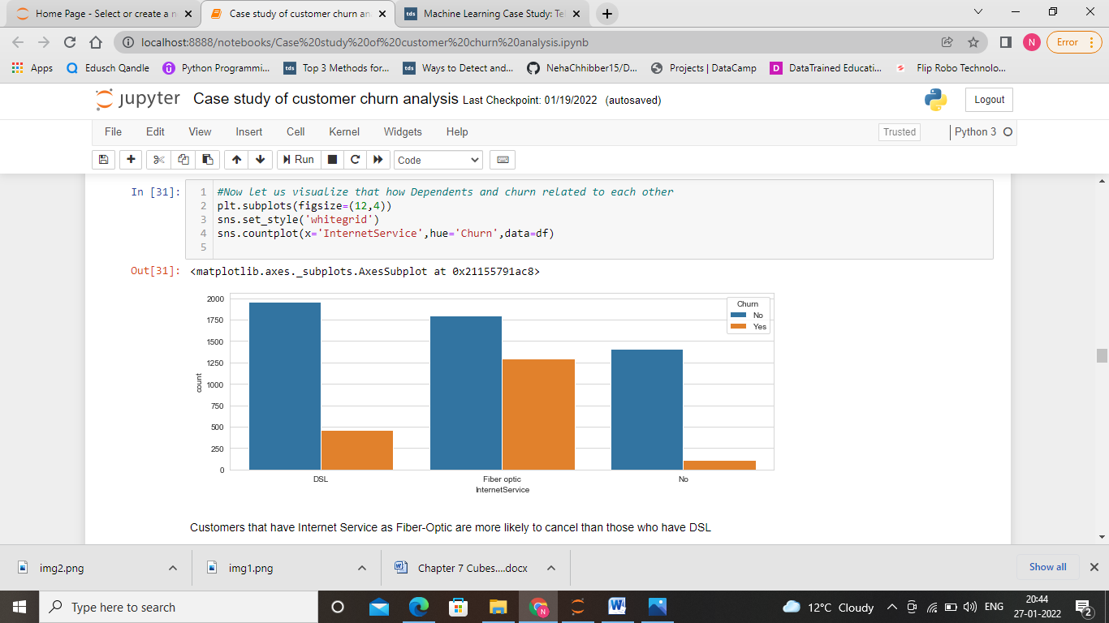

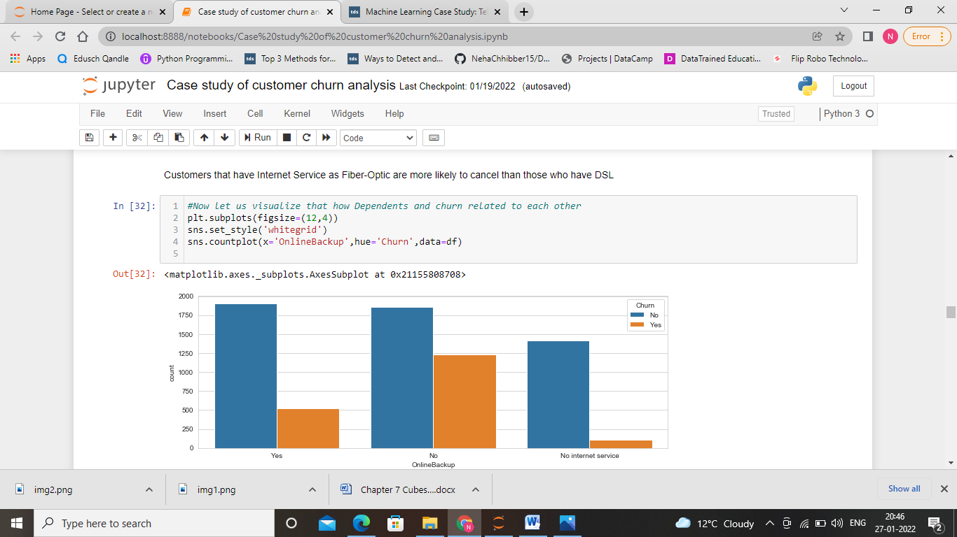

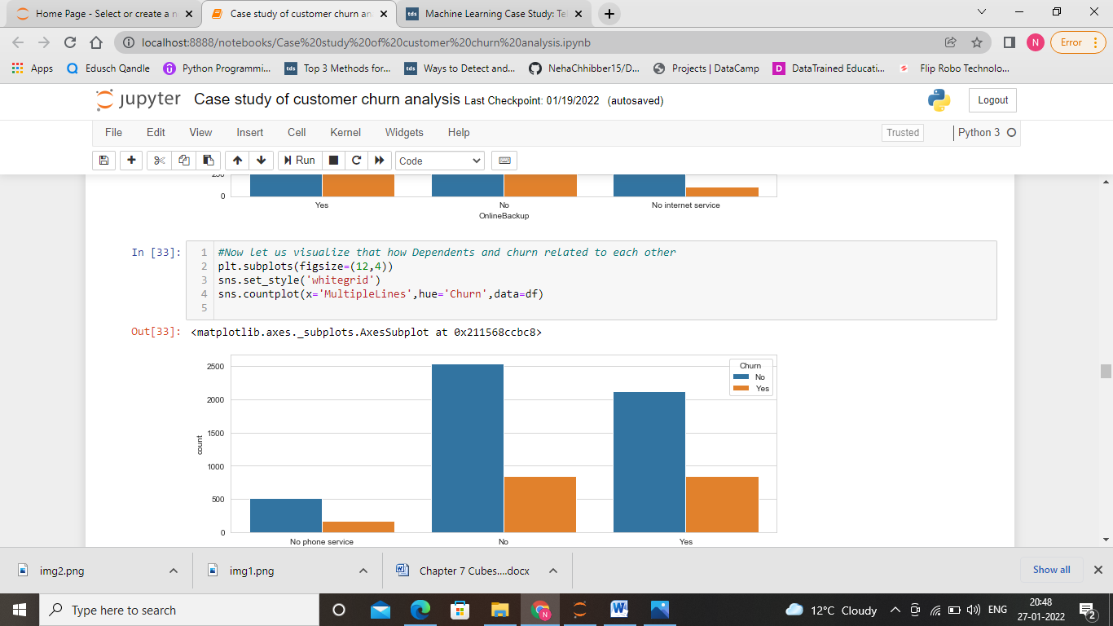

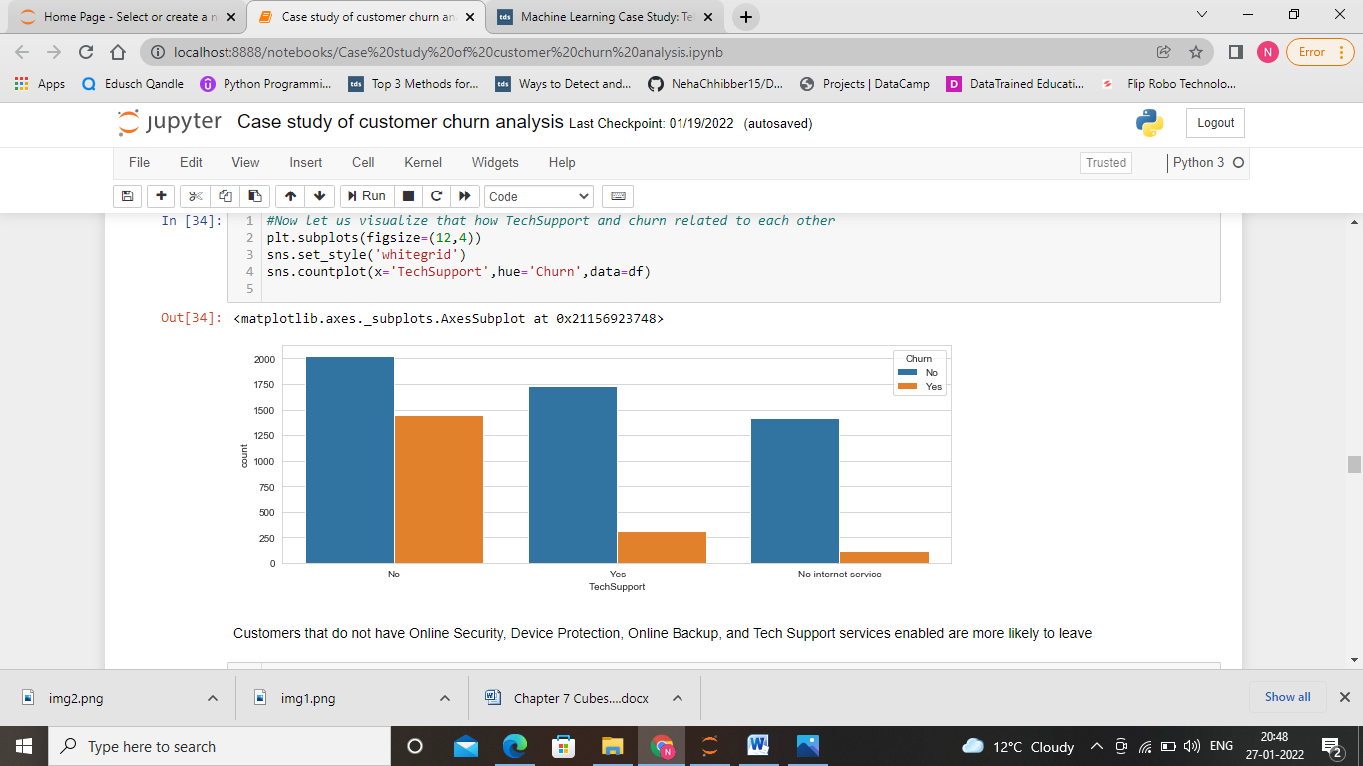

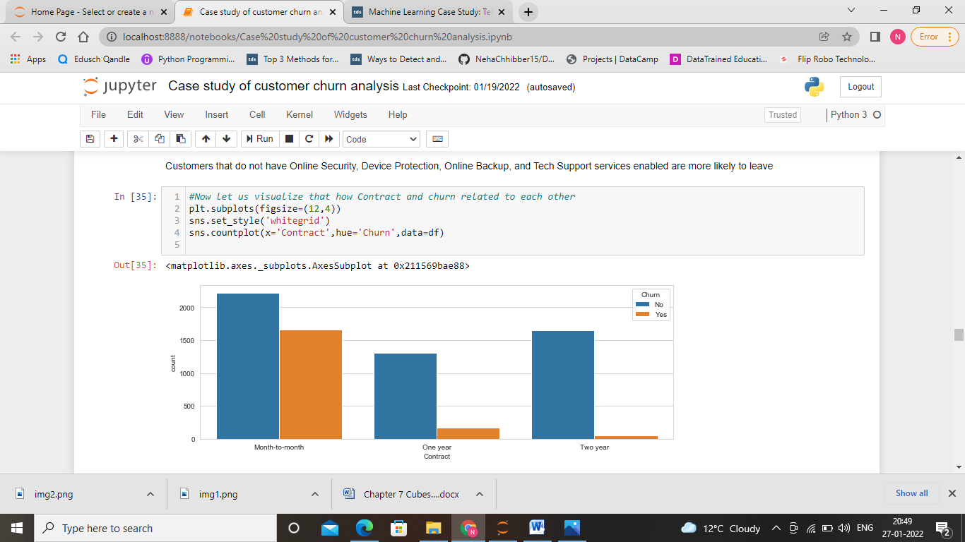

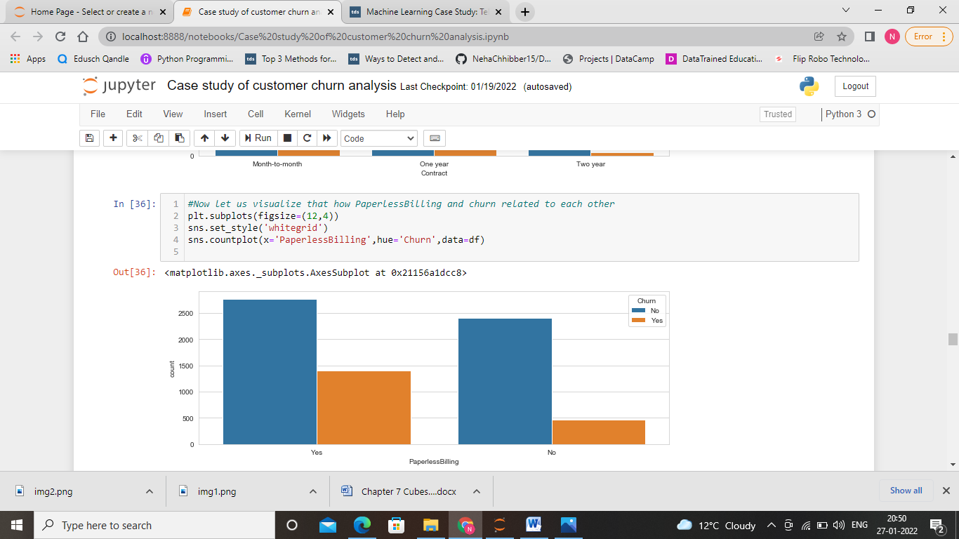

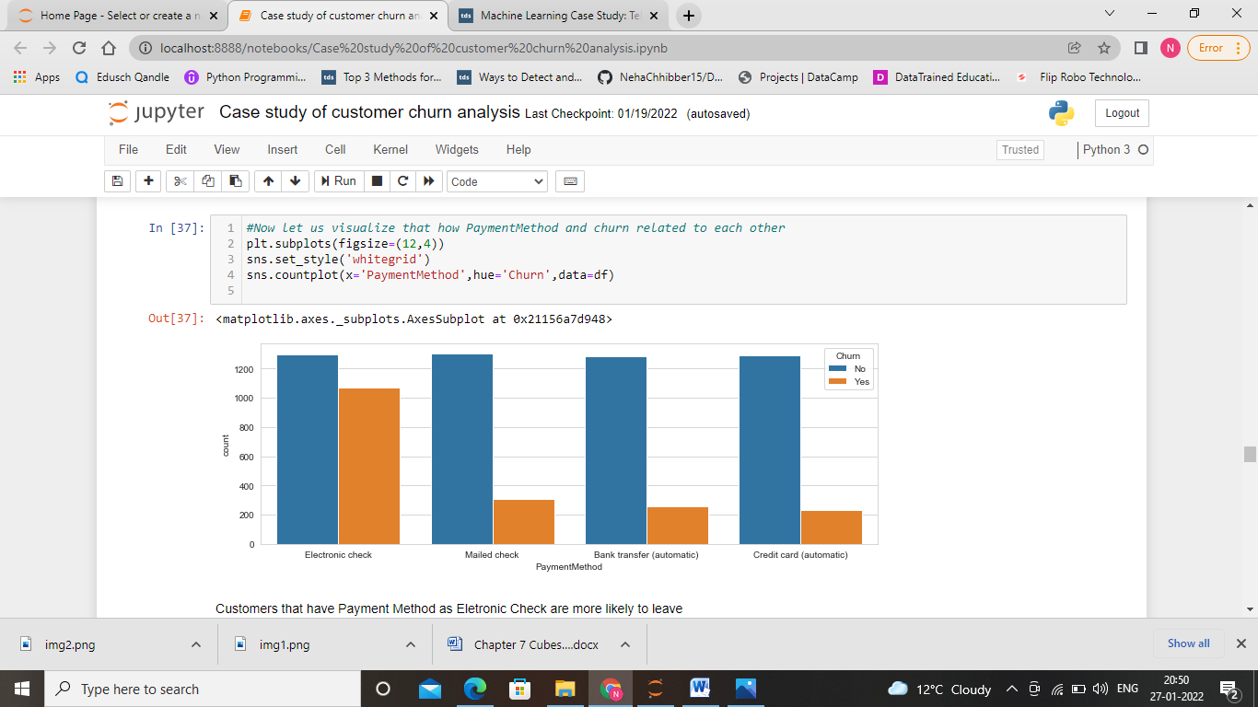

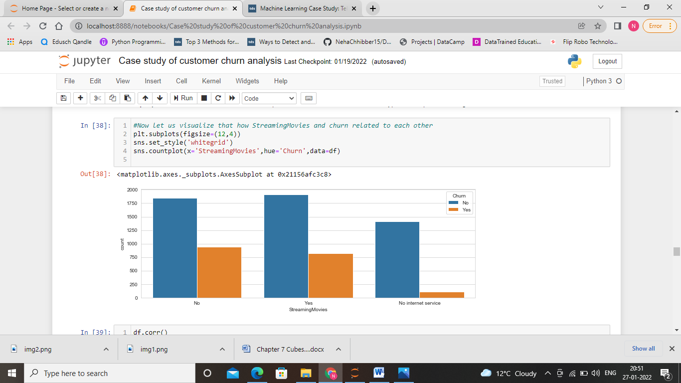

Understanding:

1. Senior citizens churn rate is much higher than non-senior churn rate. Maybe Senior citizens feel less comfortable in switching their services again and again.

2. Churn rate for month-to-month contracts much higher that for other contract durations. For monthly contract they have no outstanding on the company so they feel open to switch the services without any amount loss.

3. Churn rate for the customer having no partner and without children is higher. Because they are not dependent on the other’s need. So they feel open to switch the services.

4. Payment method electronic check is less likely among the people so they shows much higher churn rate than other payment methods.

5. Customers with Internet Service fiber optic as part of their contract have much higher churn rate.

6. More expensive contracts lead to increased churn as the chances to save money by changing providers might be higher.

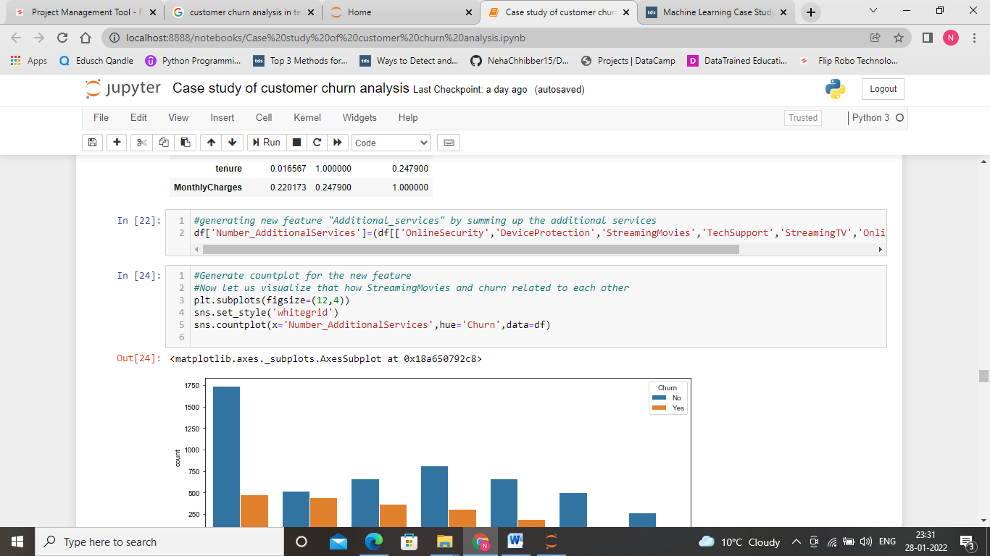

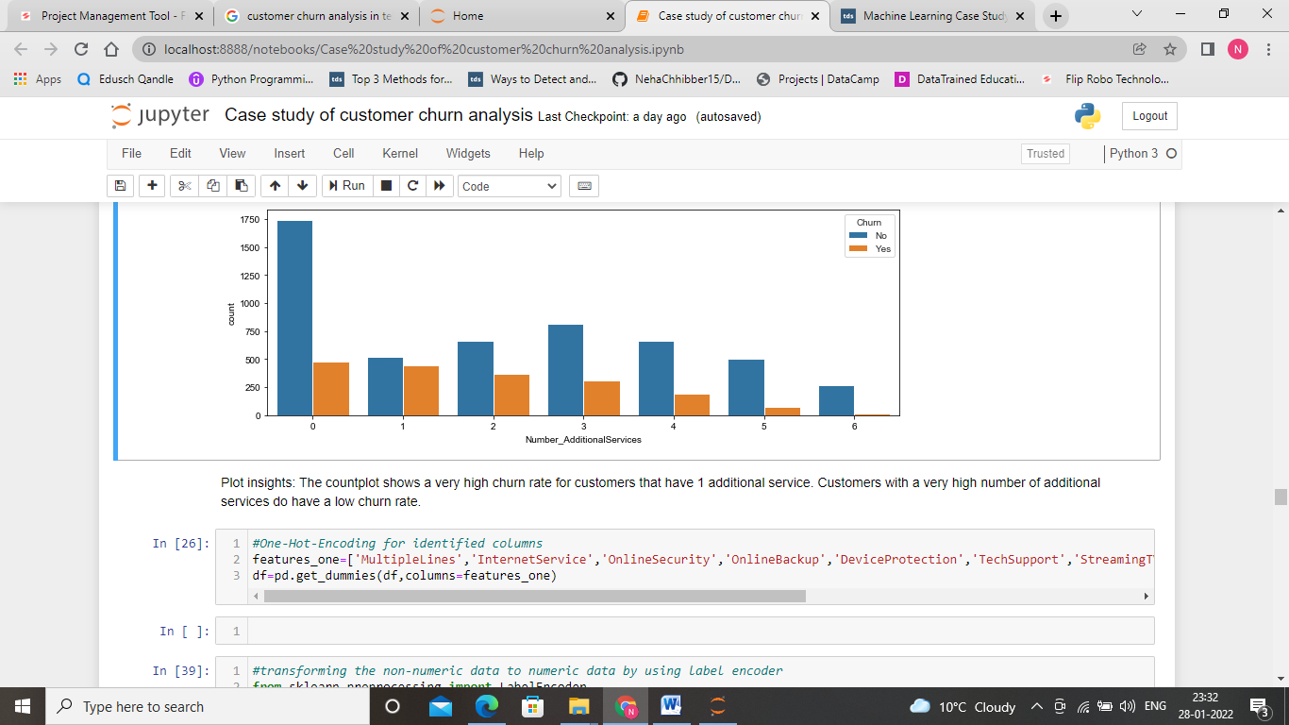

**Checking Outliers**

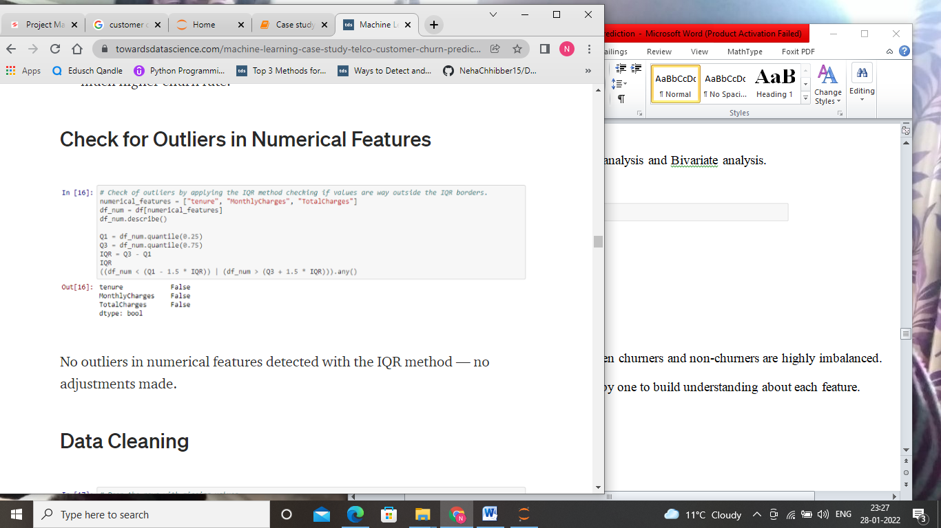

Here, we can see that there is no outliers present in the numerical features.

**Feature Engineering**

It is a method of selecting and short listing features as per correlation with the target variable. Moreover, sometime additional features are also created from the existing features and a correlation analysis is conducted after all features have been transformed to numerical.

Feature Selection

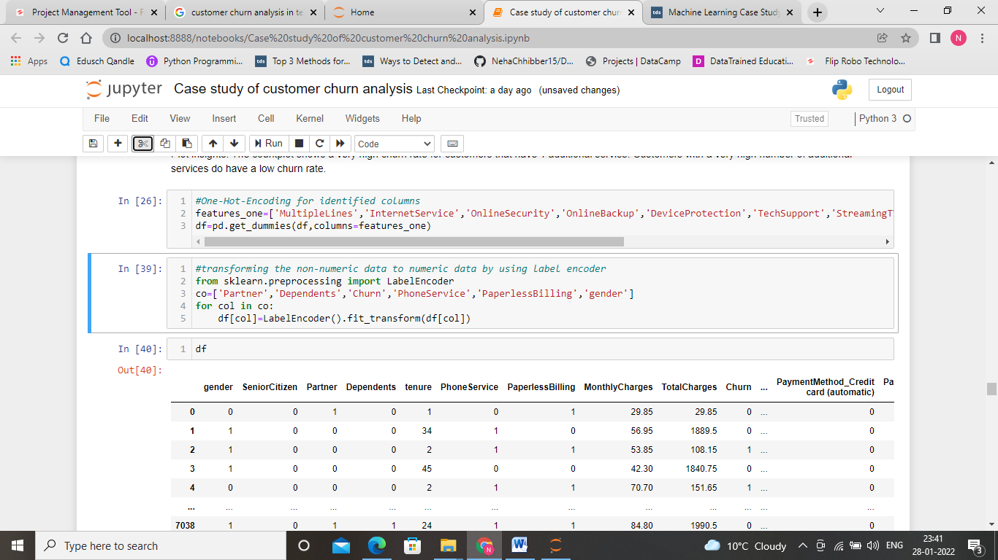

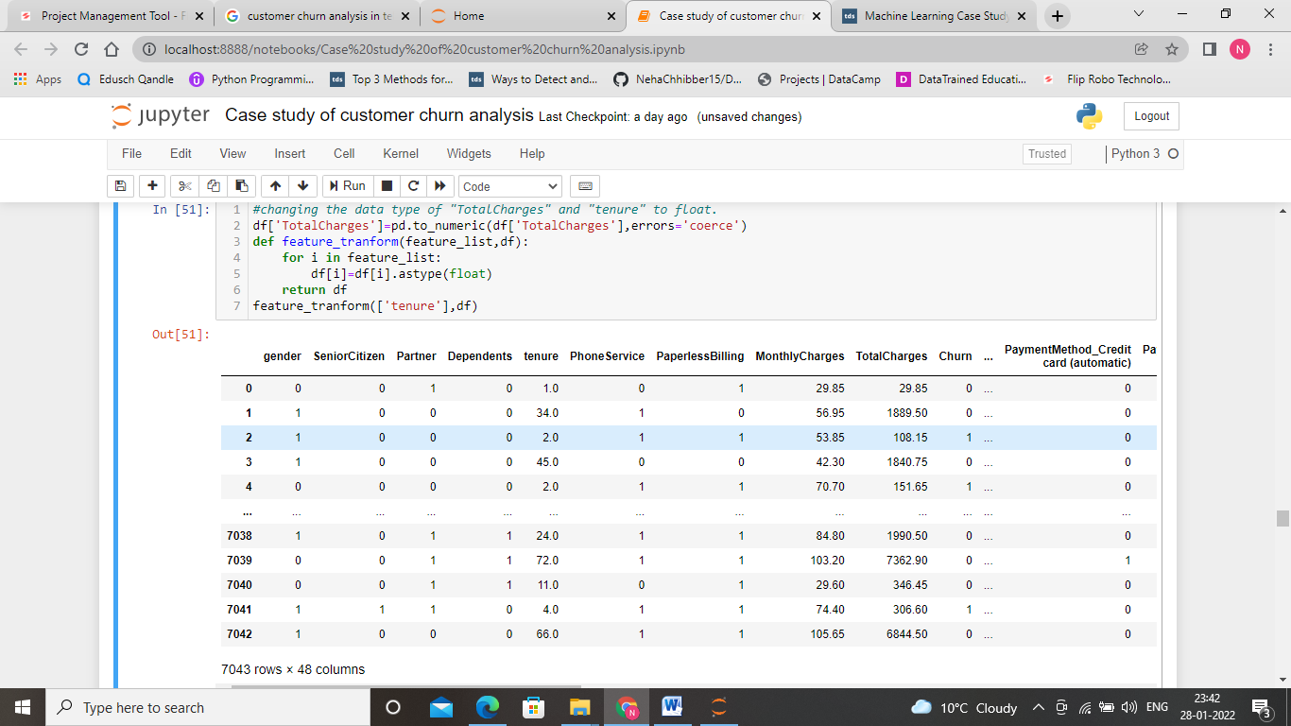

Feature rescaling

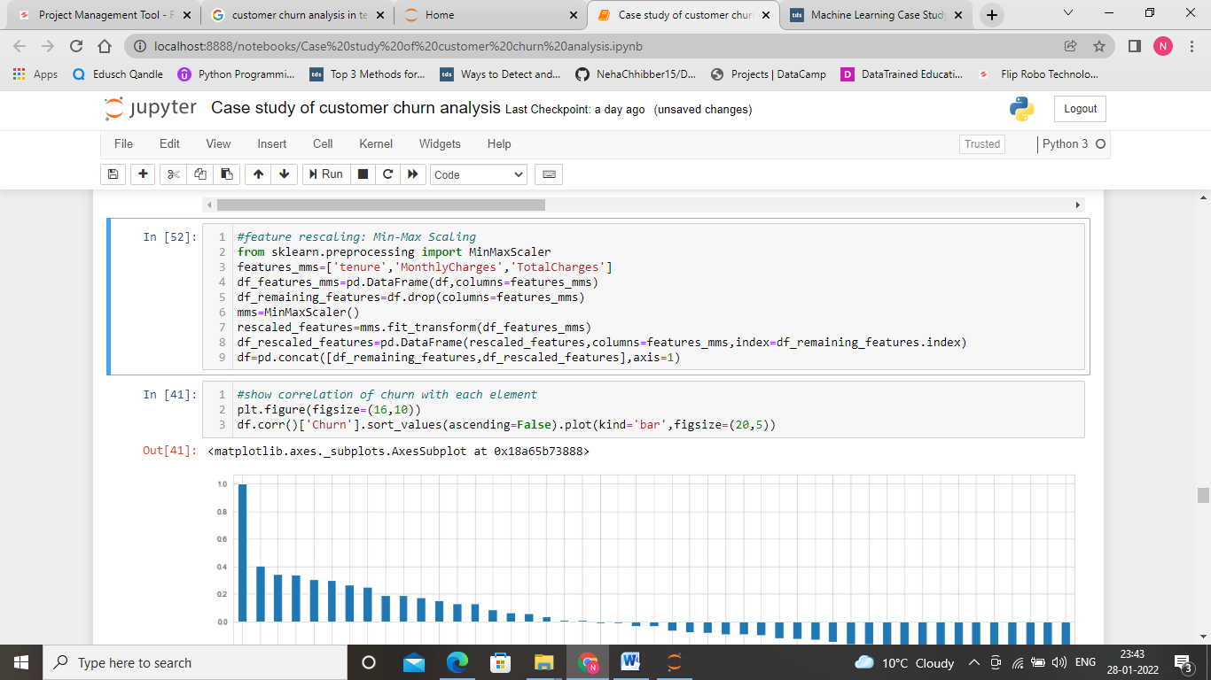

Correlation analysis

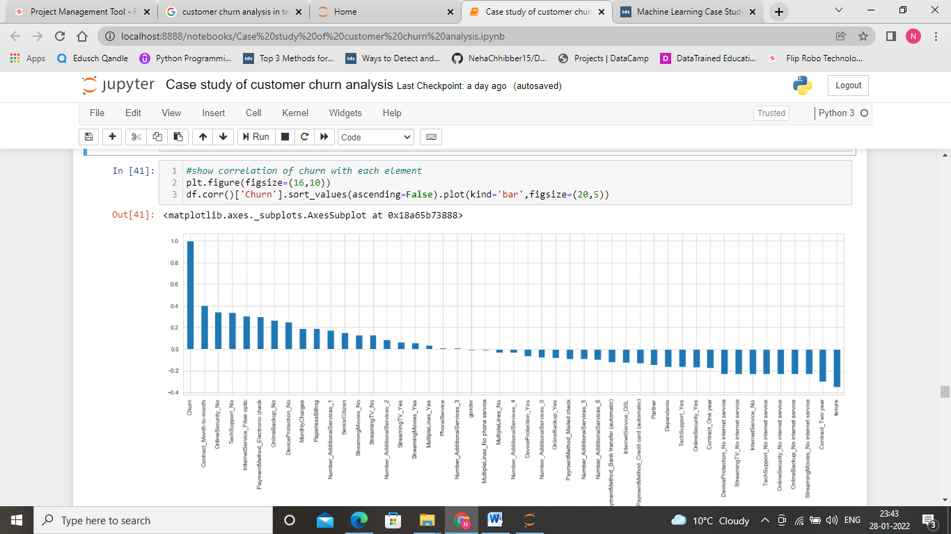

**Train/Test Split, Model Evaluation Metrics Definition**

For conduction of model training and testing steps, the data set is split into 80% training data and 20% test data. The “Churn” column is defined as the class (y), the remaining columns as the features (the x).

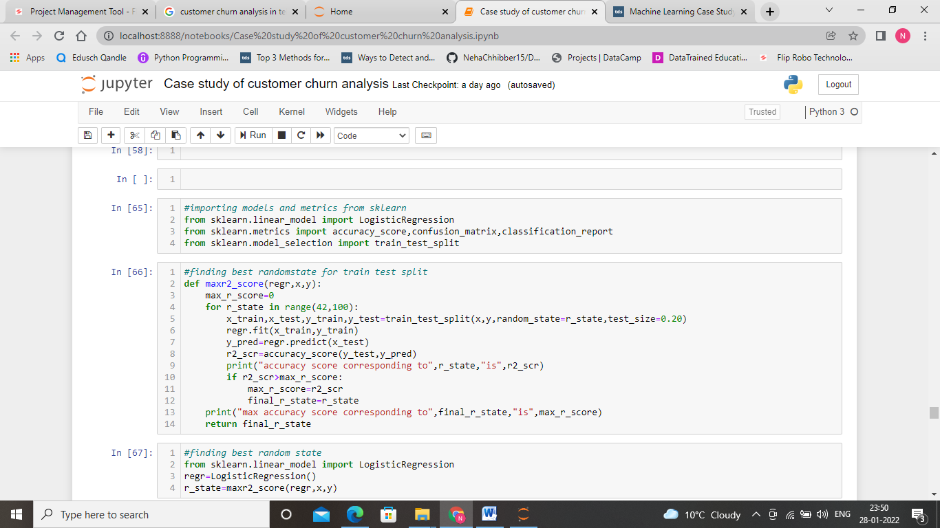

Here, we are finding best random state for getting better accuracy.

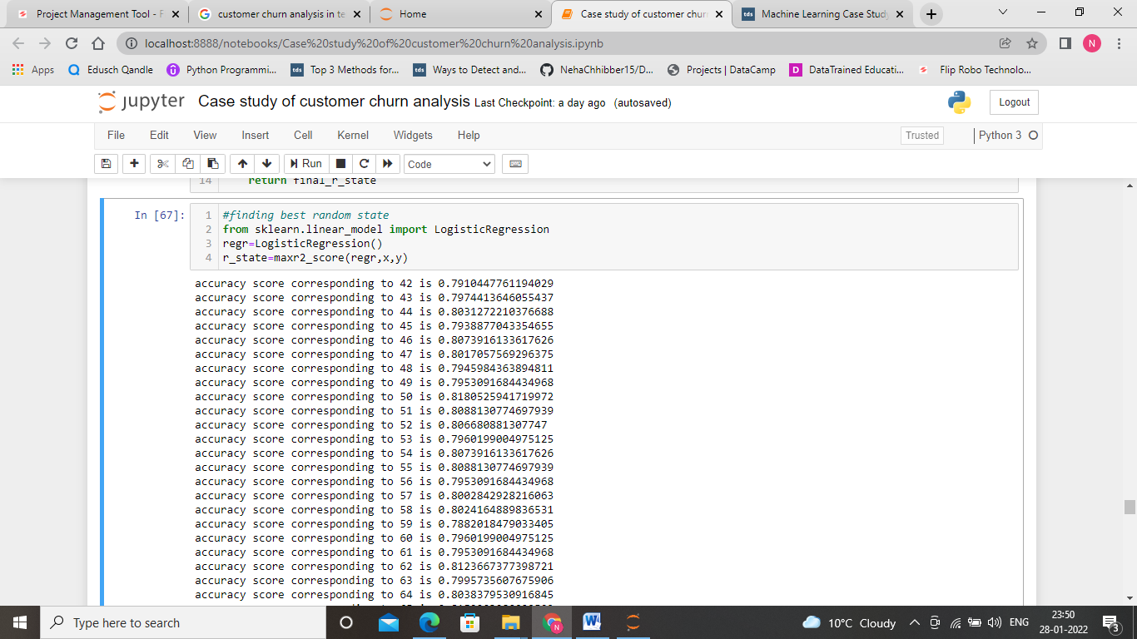

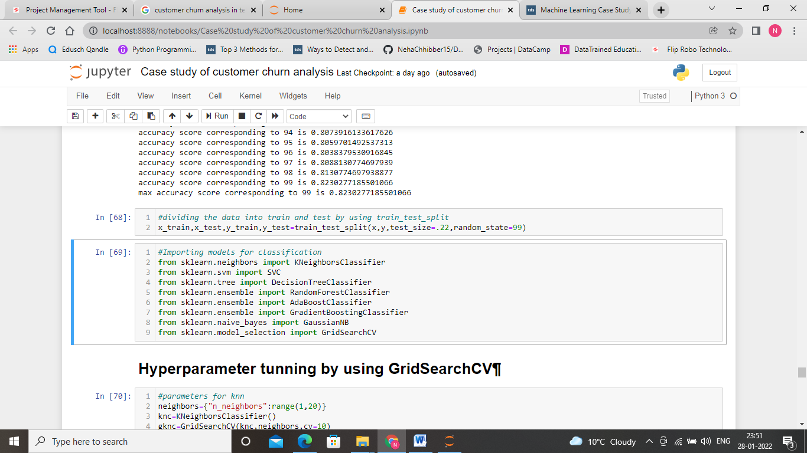

**Hyperparameter Tuning ,Model Selection, Training, Prediction and Assessment**

Here, we are testing out several models and measure their performance by several metrics. Those models optimised by doing hyperparameters tunning using grid search cv. The models used include:

* 1. **K Nearest Neighbors**
  2. **Random Forest**
  3. Decision Tree
  4. Support Vector Machines
  5. Adaboost
  6. Gradiantboost
  7. GausianNB
  8. Logistic Regression

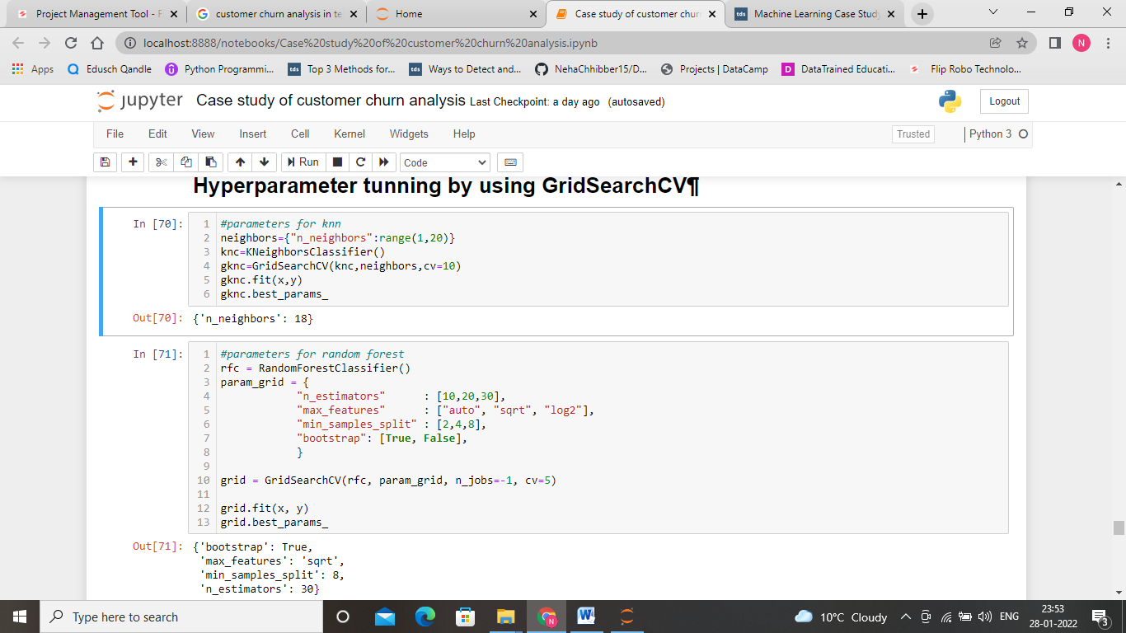

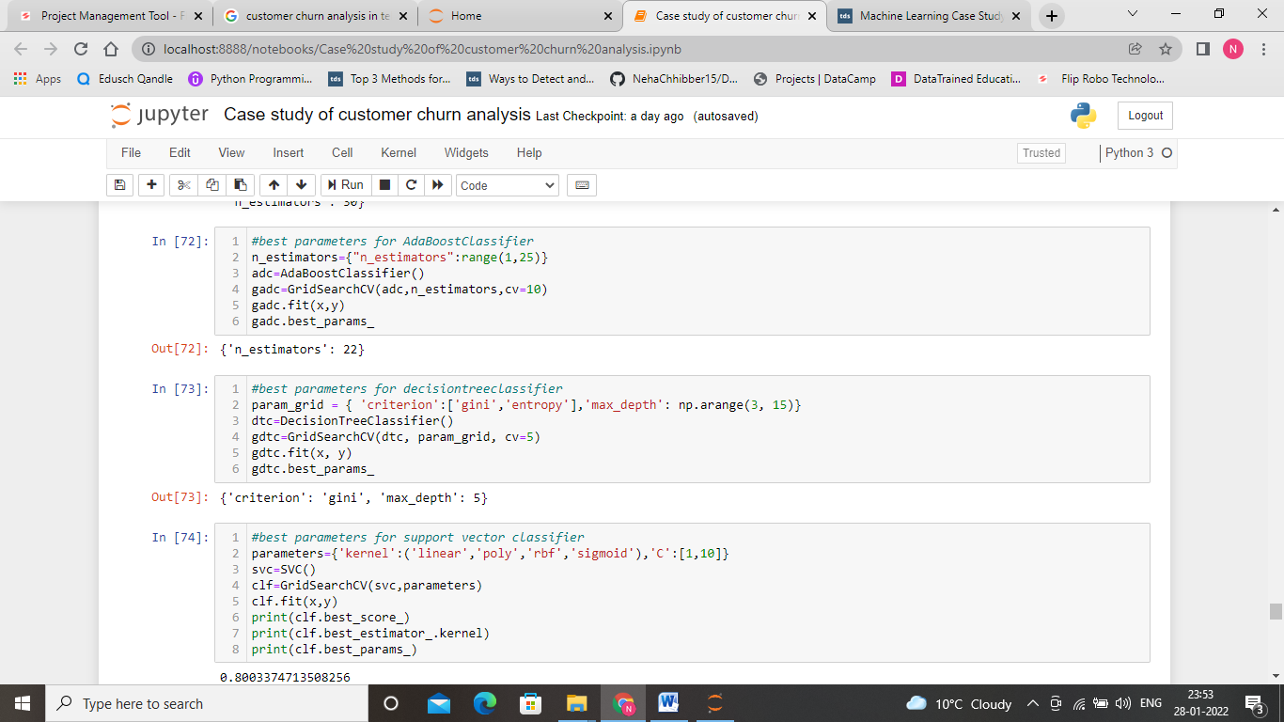

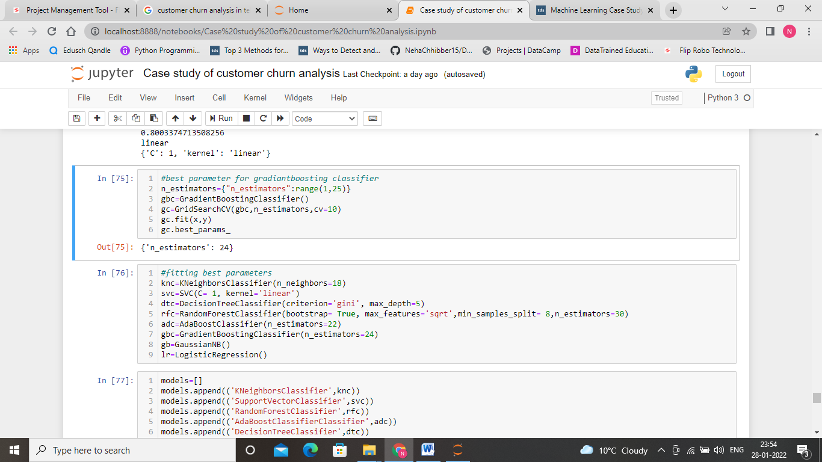

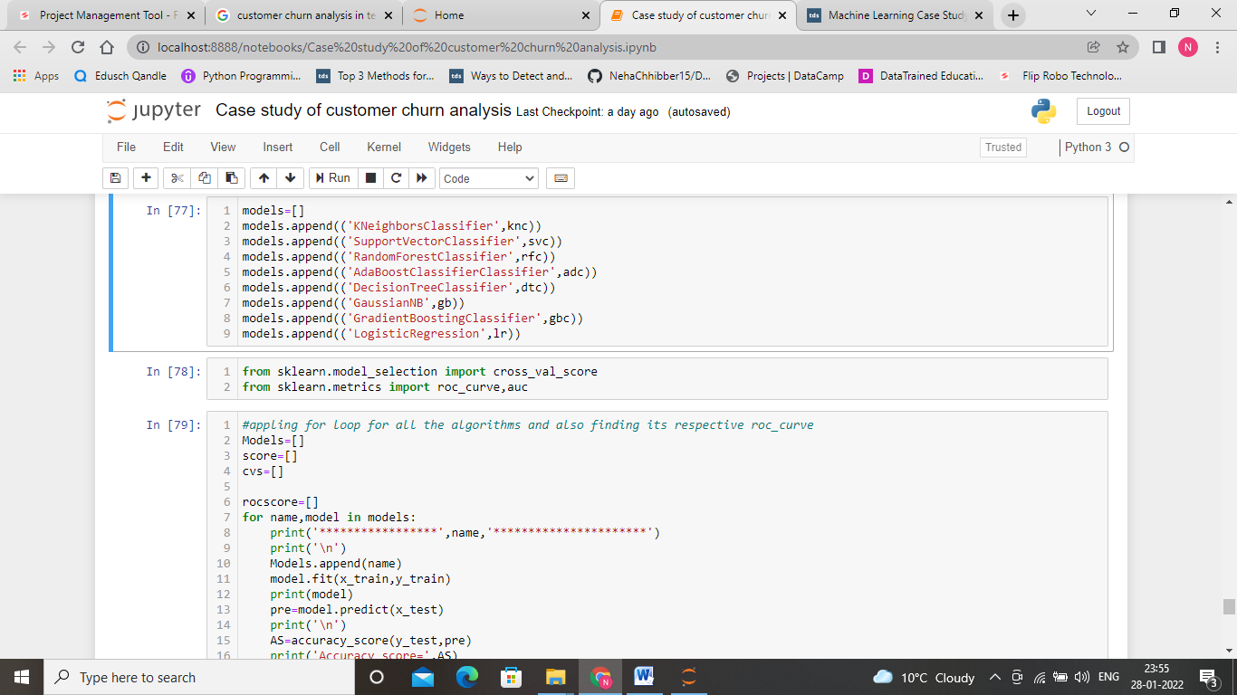

To check the performance of model, we have used various models such confusion matrix, accuracy score, ROC curve, AUC, precision, recall, F1 score.

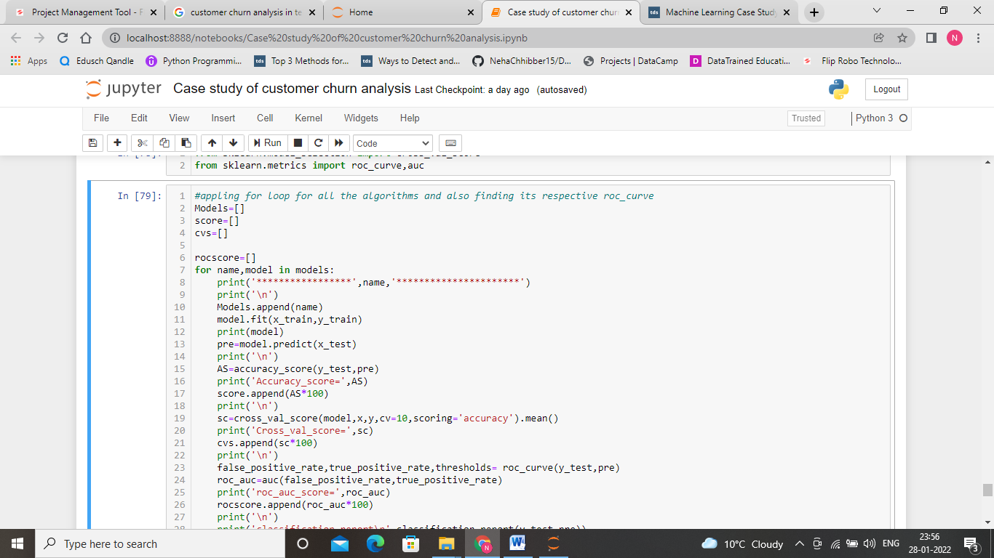

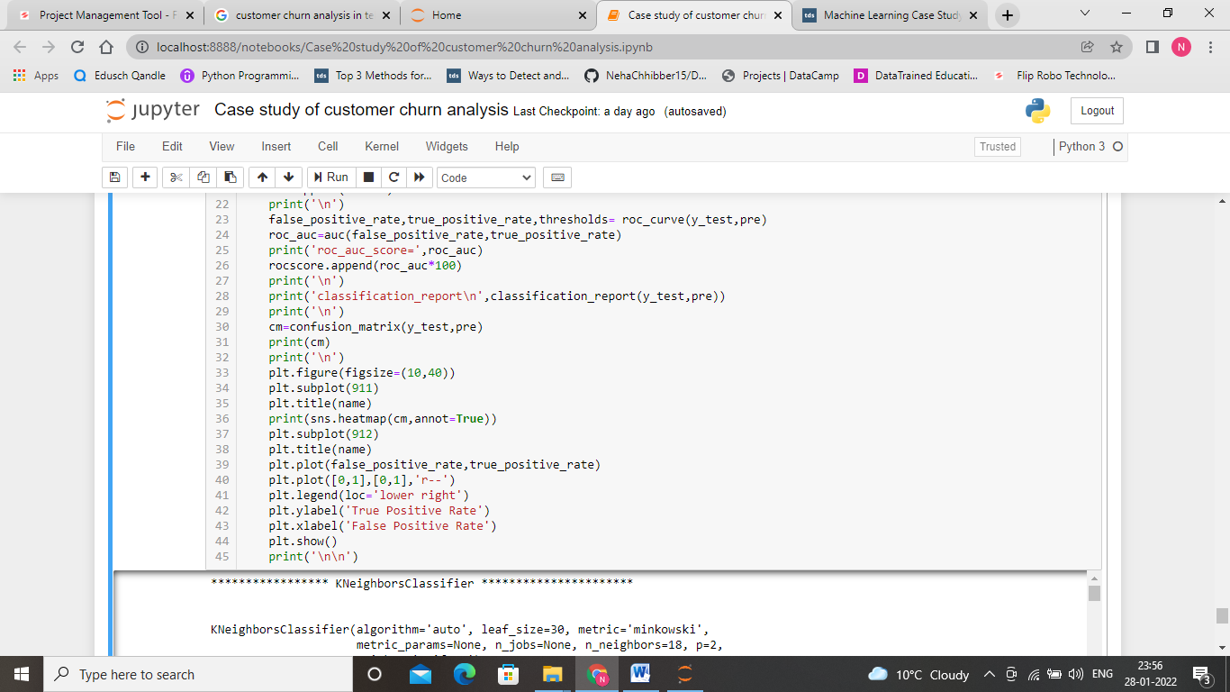

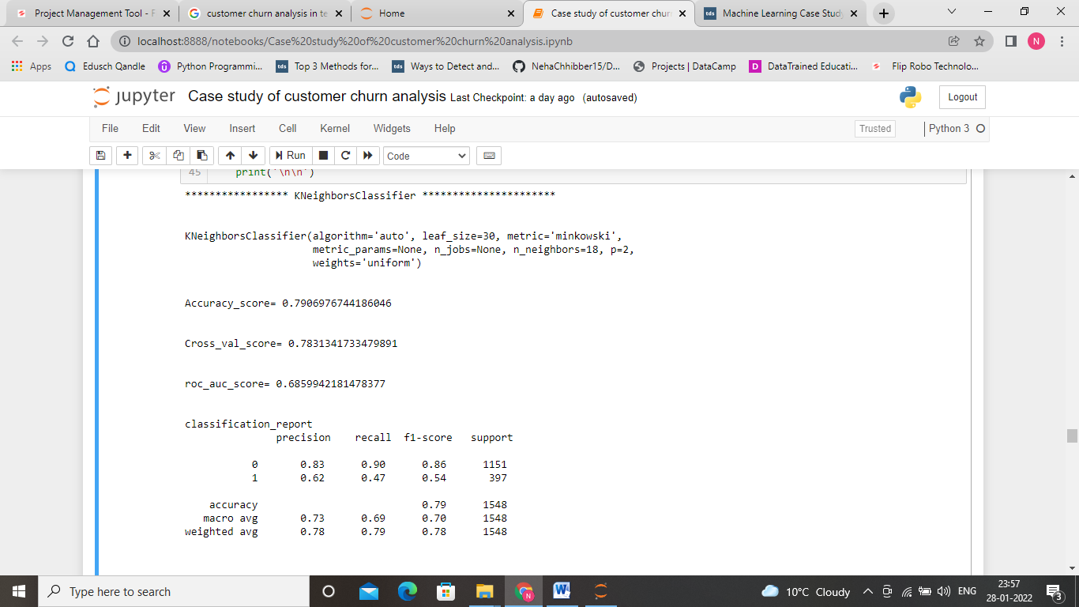

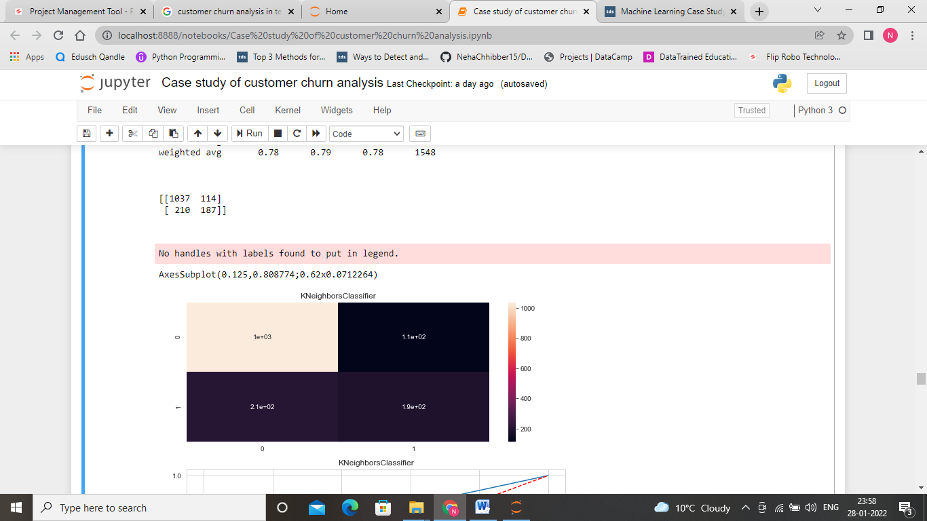 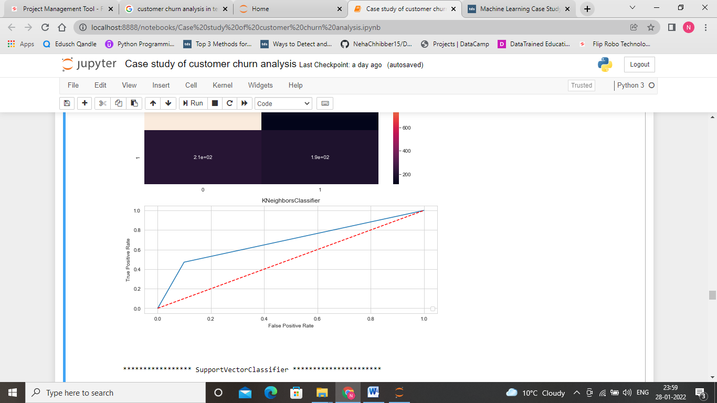

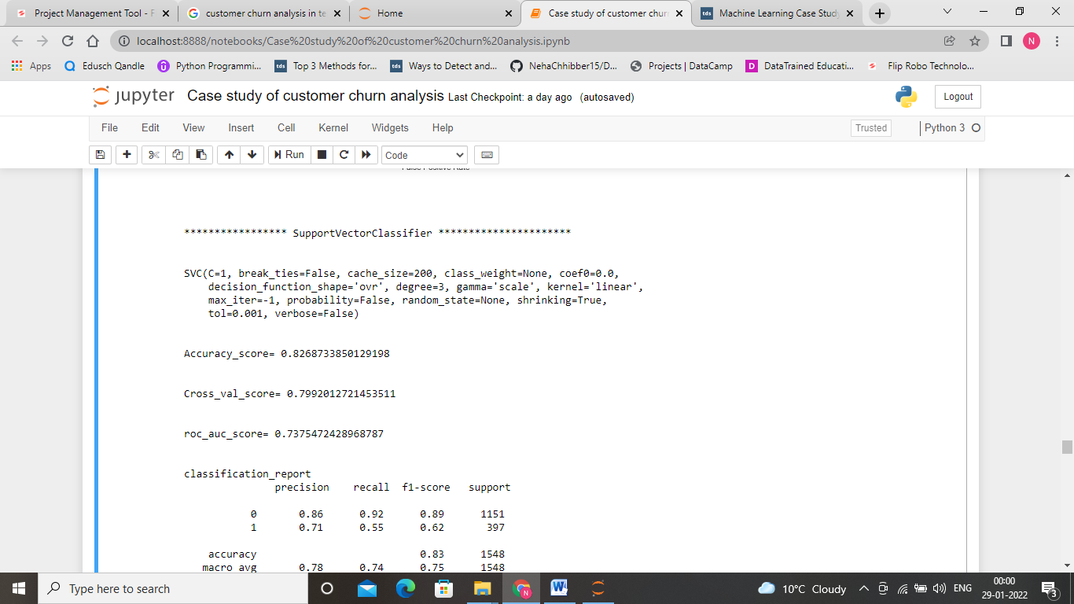

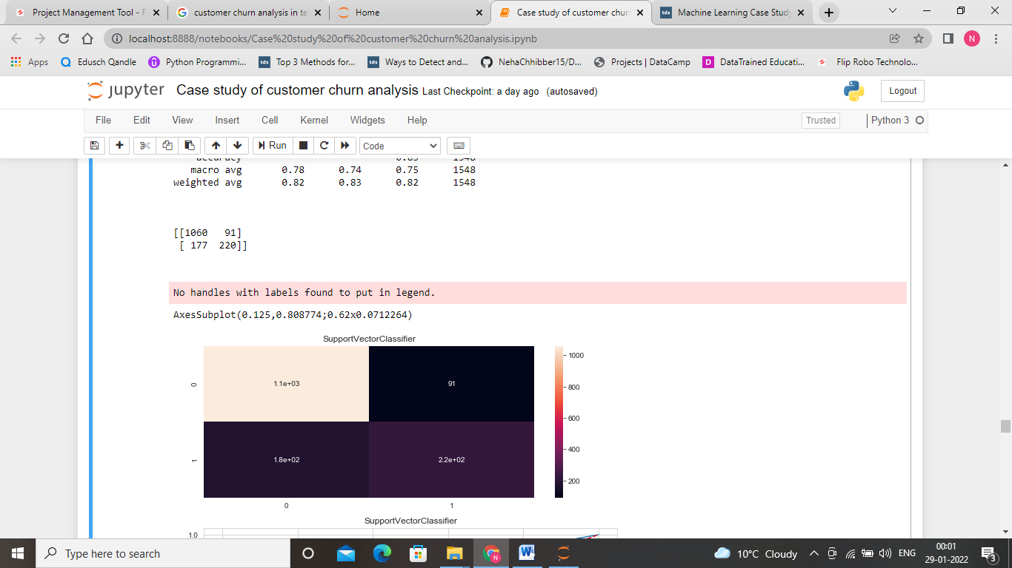

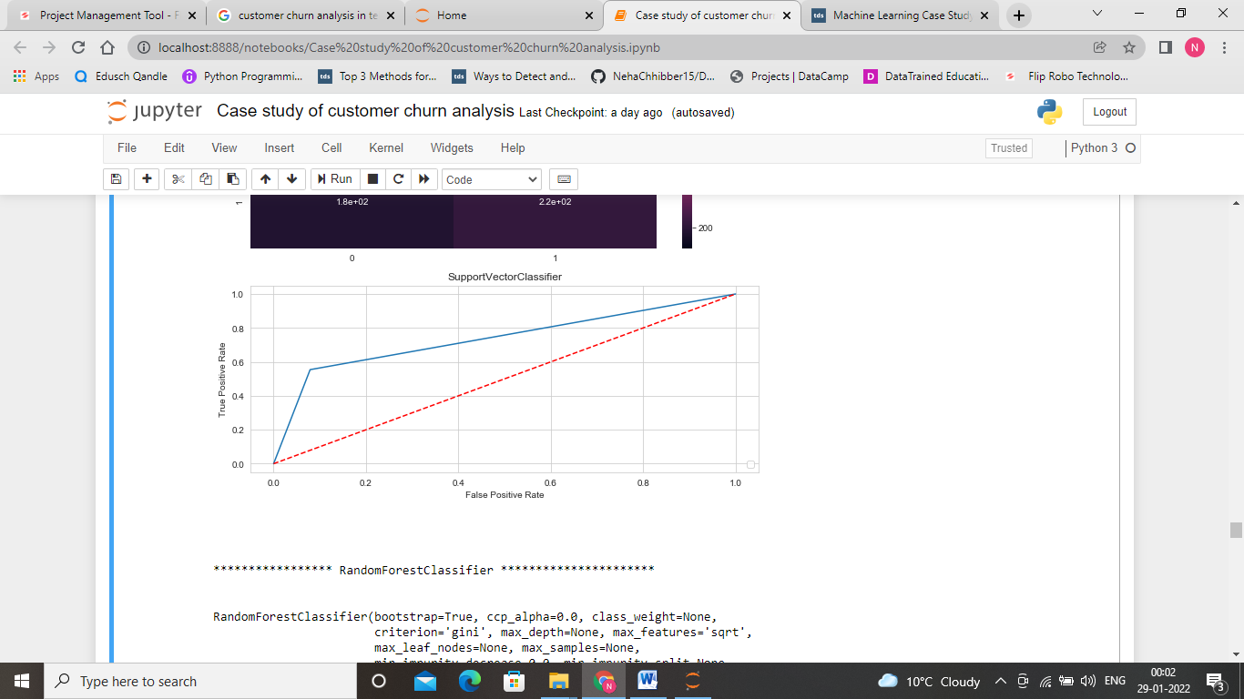

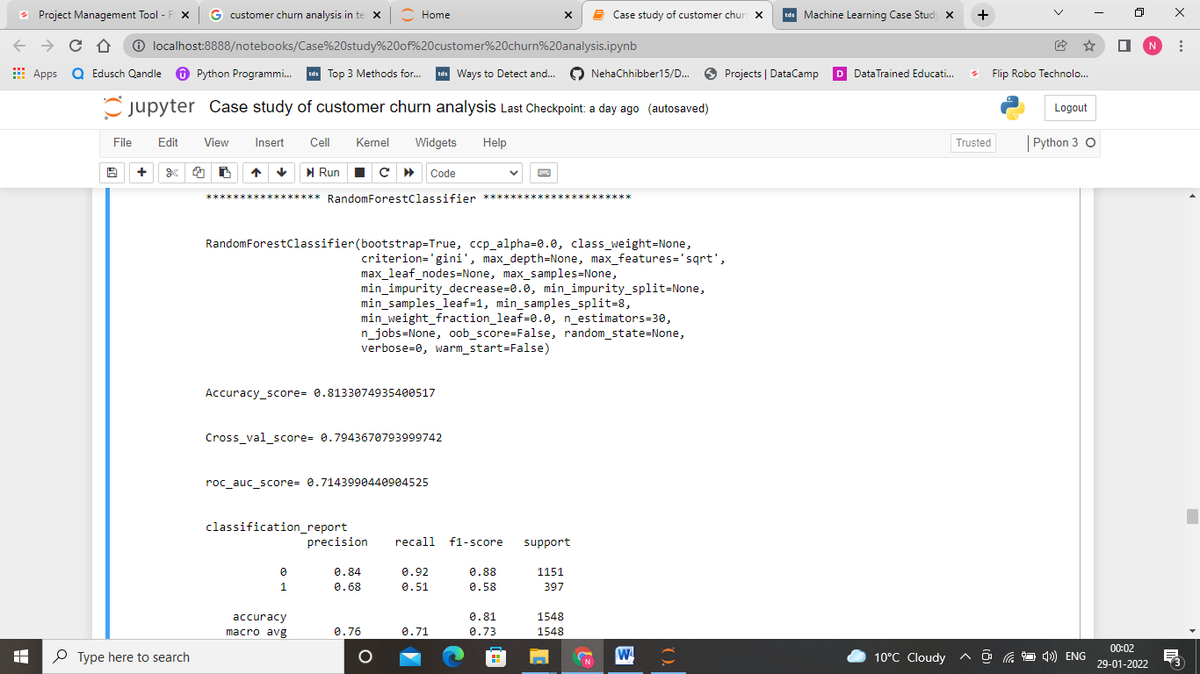

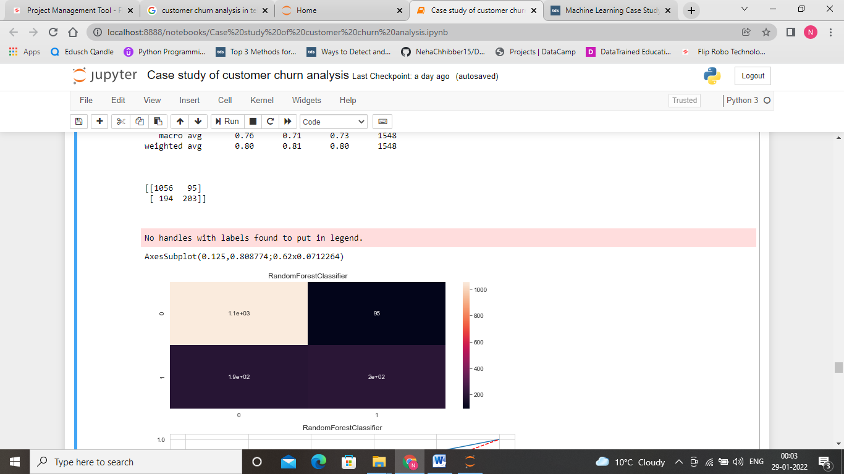

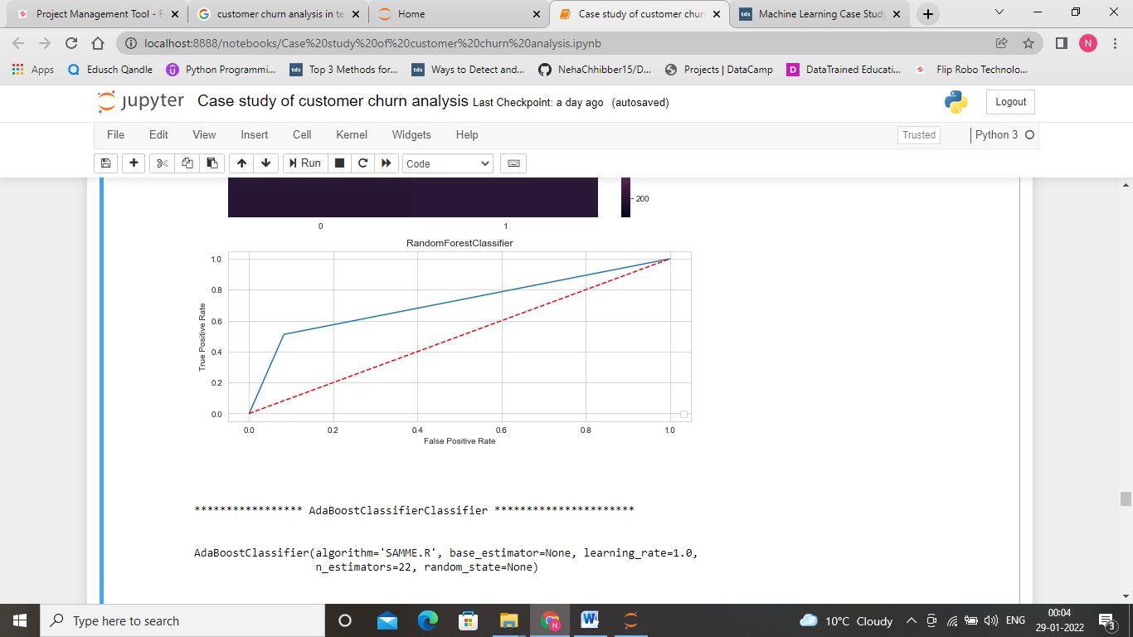

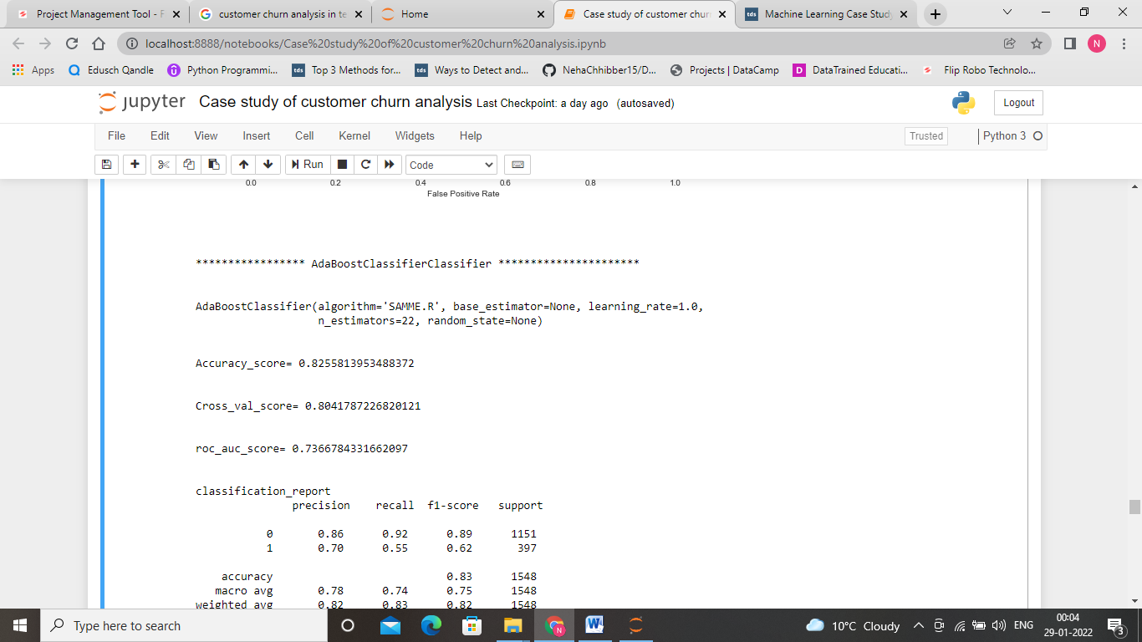

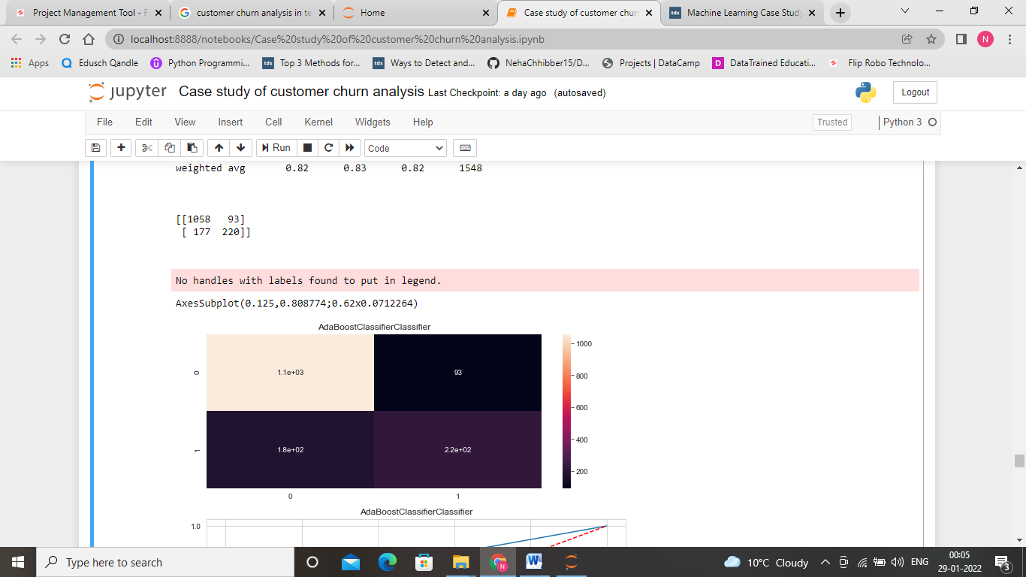

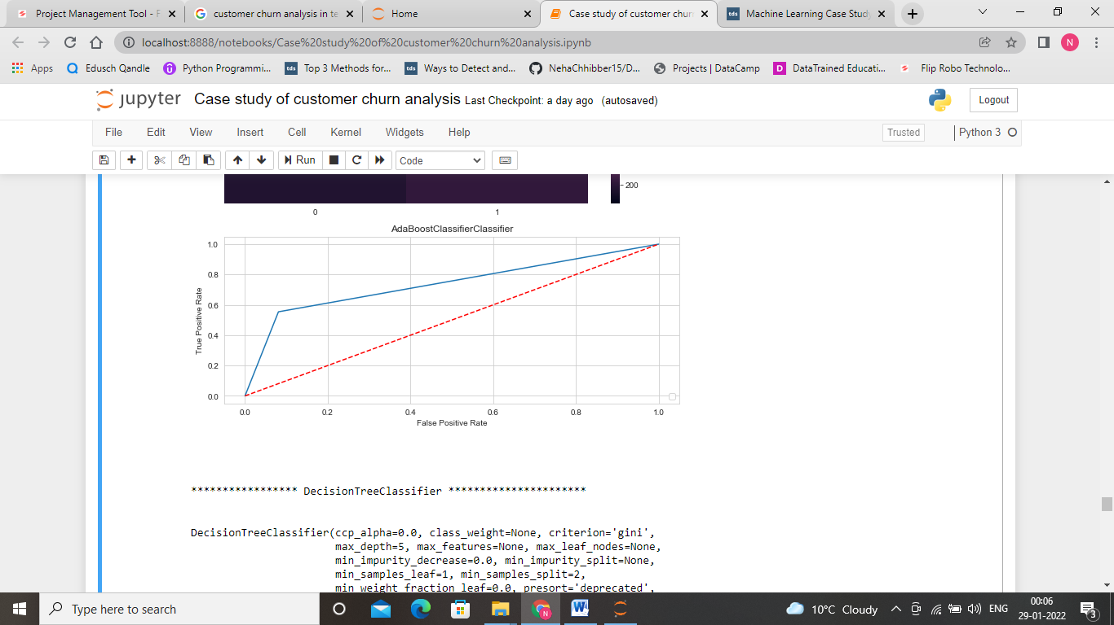

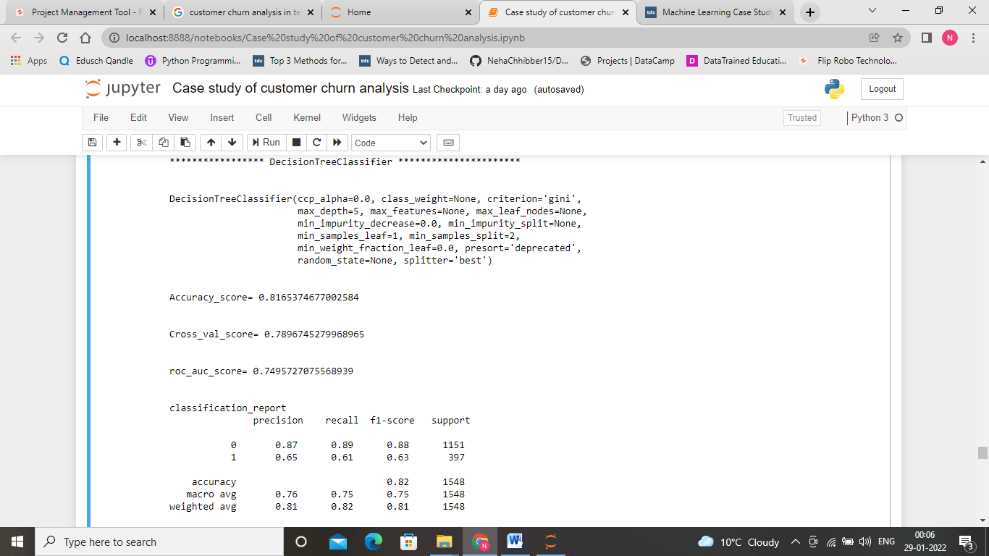

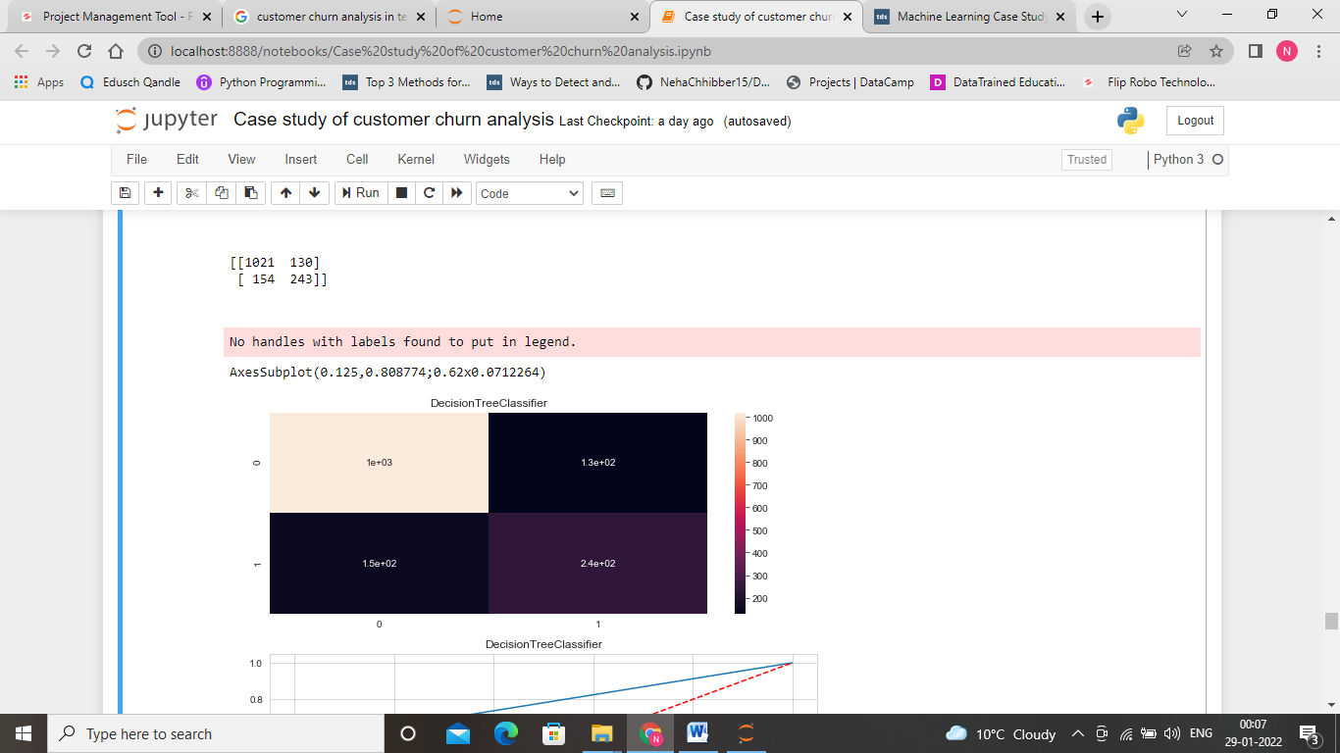

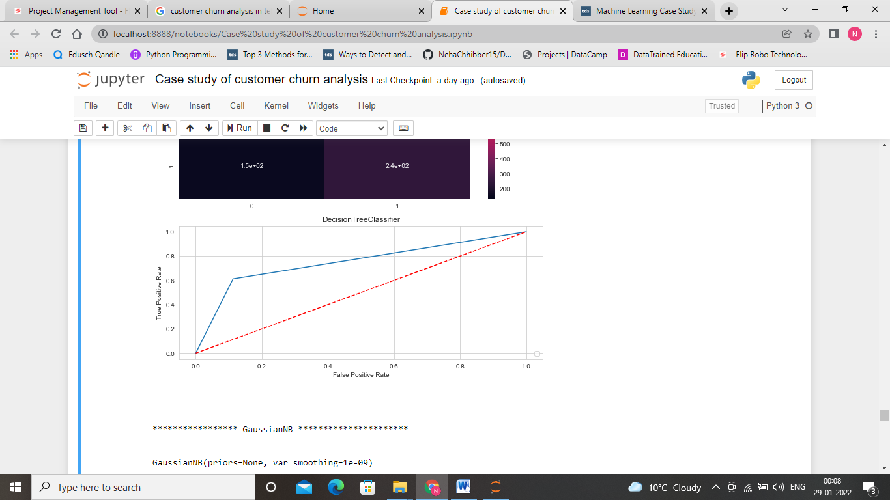

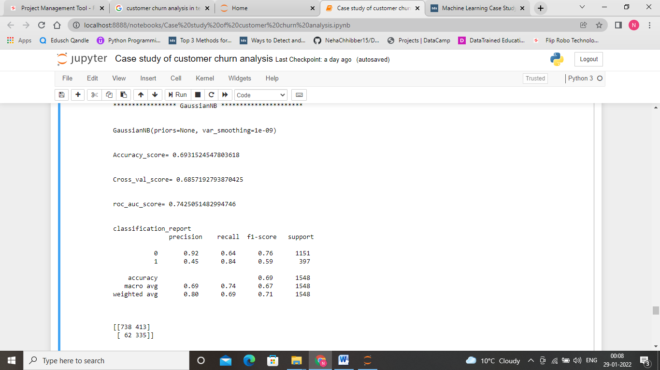

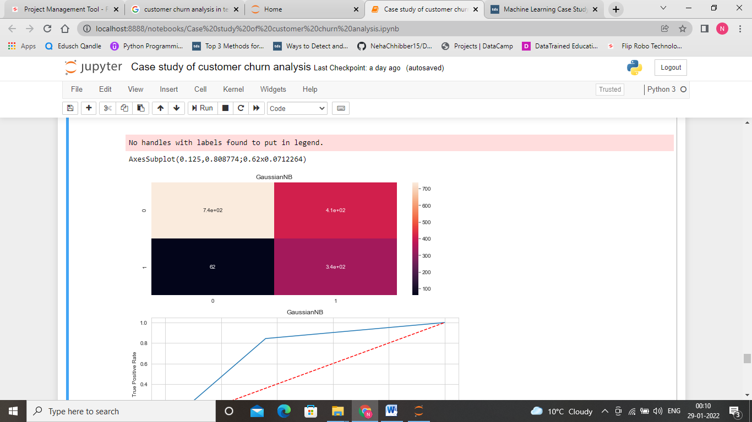

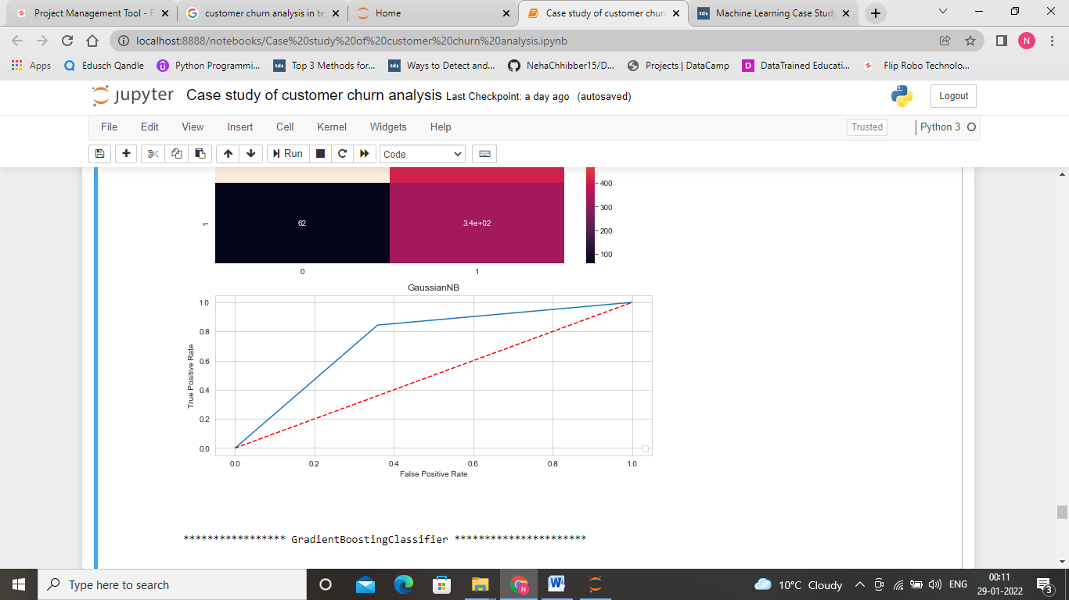

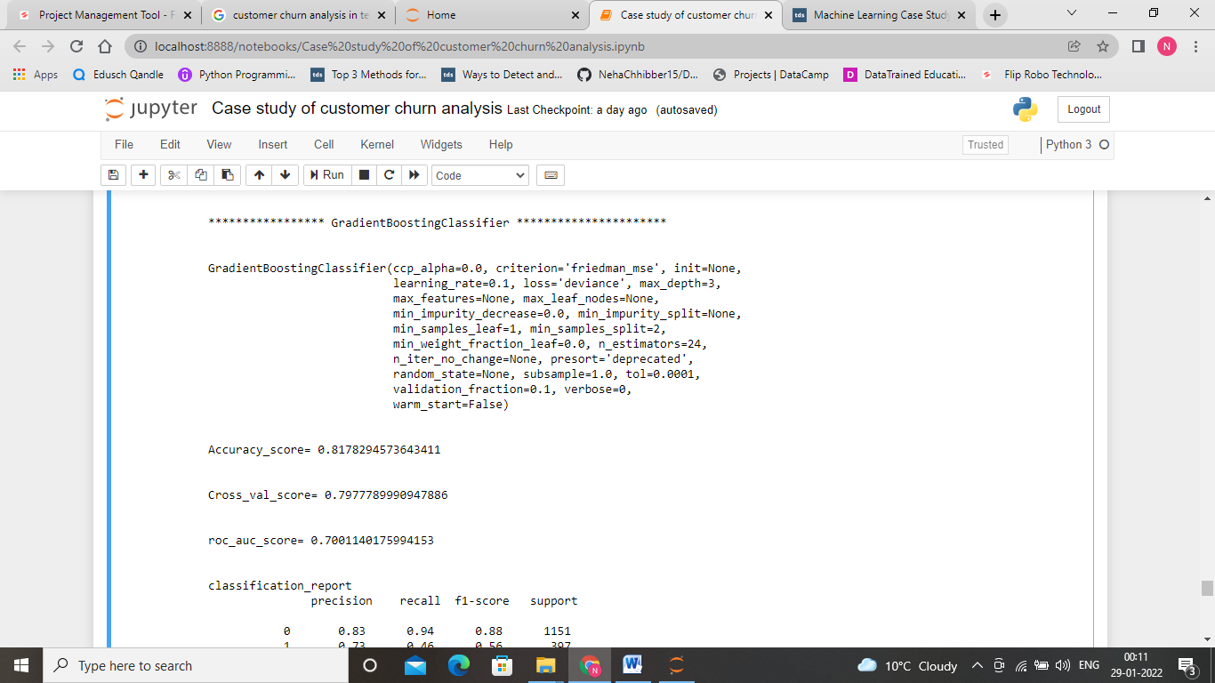

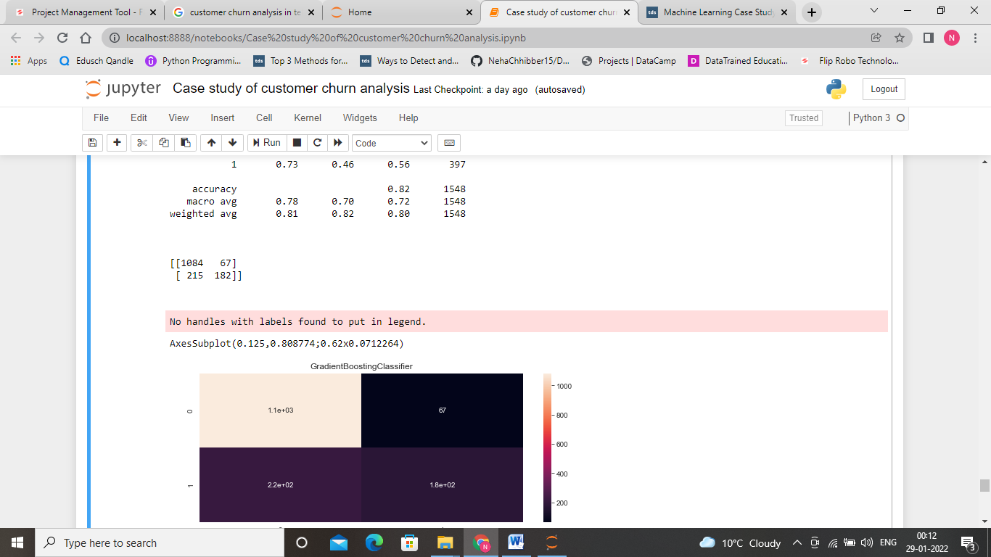

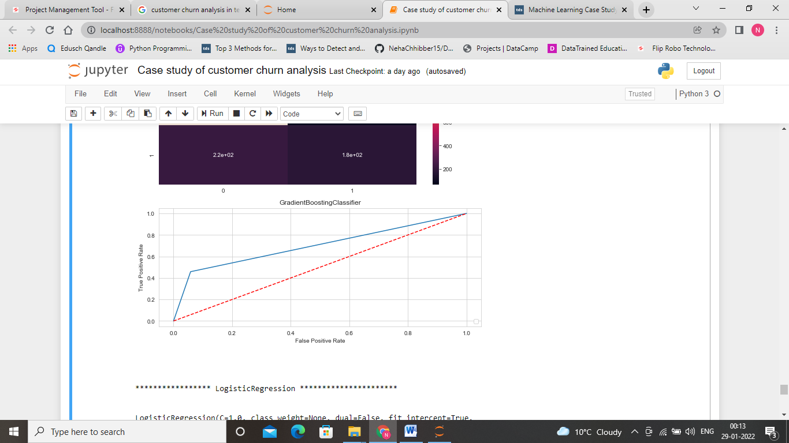

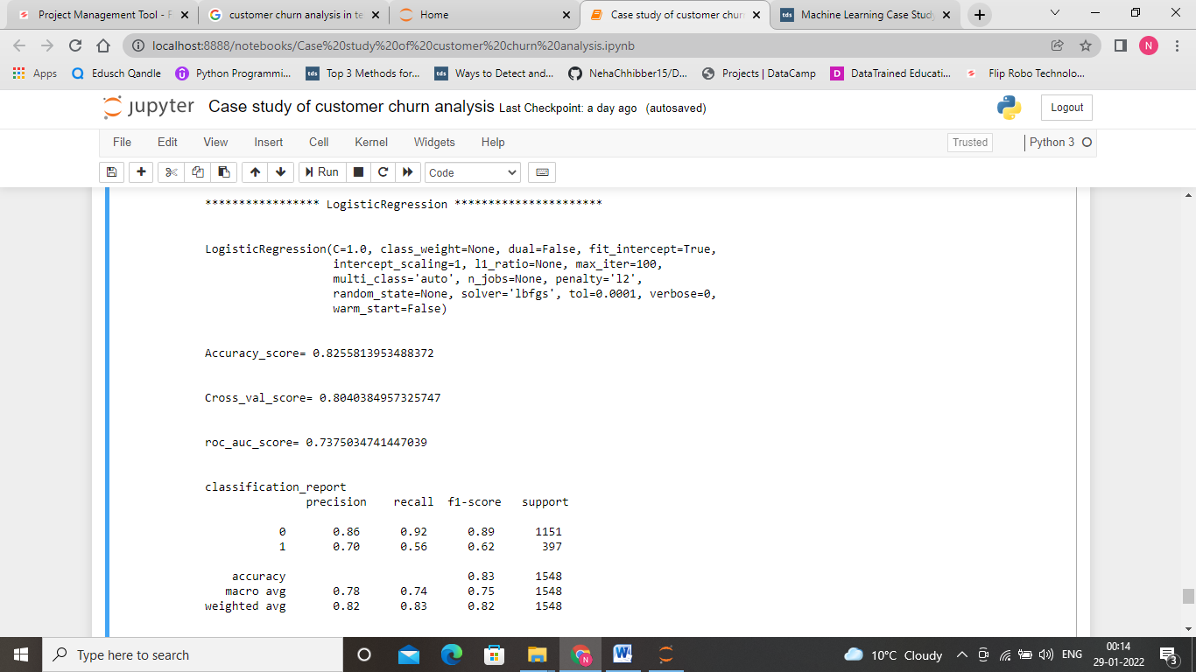

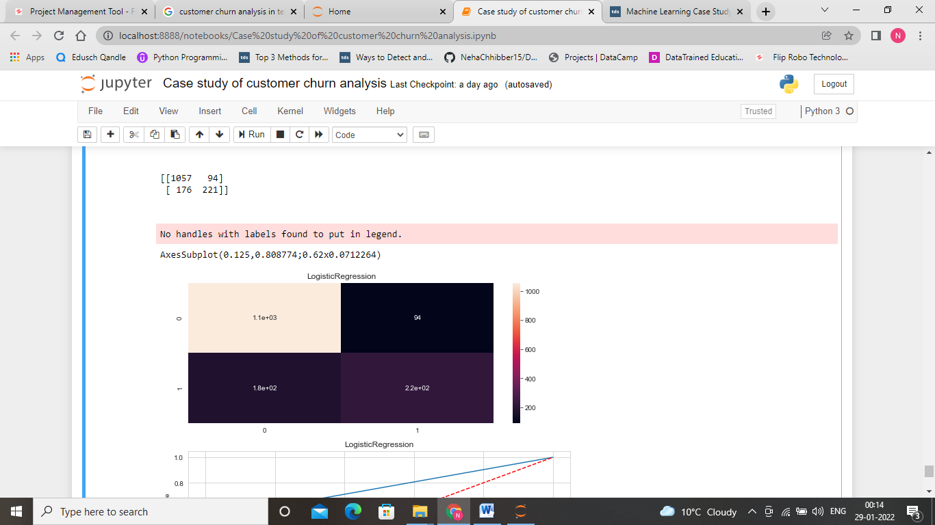

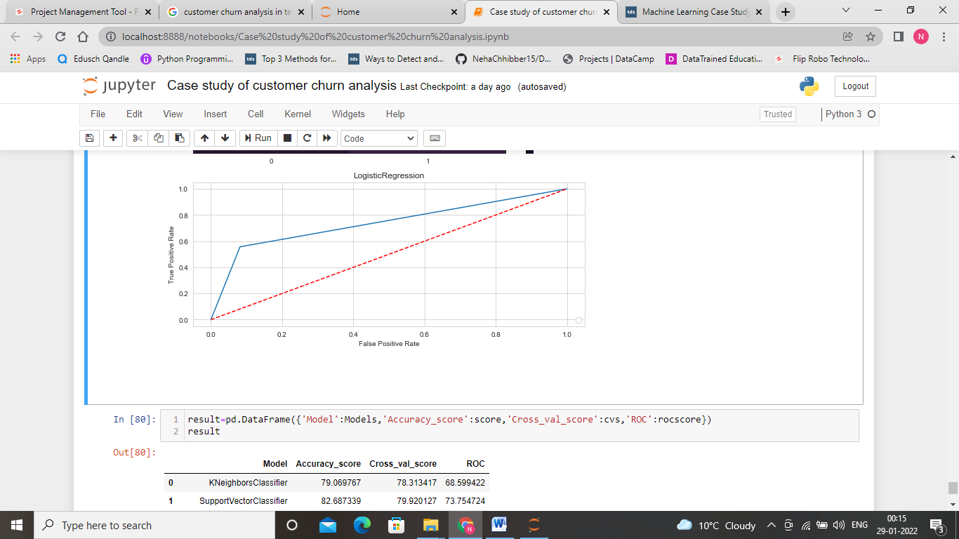

**Finding Best Model**

On comparing the performance of each model with respect to their accuracy_score, cross_val_score, ROC curve. We get to know that logistic Regression is performing better as compare to other models. It is giving an accuracy score of 82.55% and cross value score of 80.40. Area enclosed under the curve is 73.8%. So, we are finalising logistic Regression.

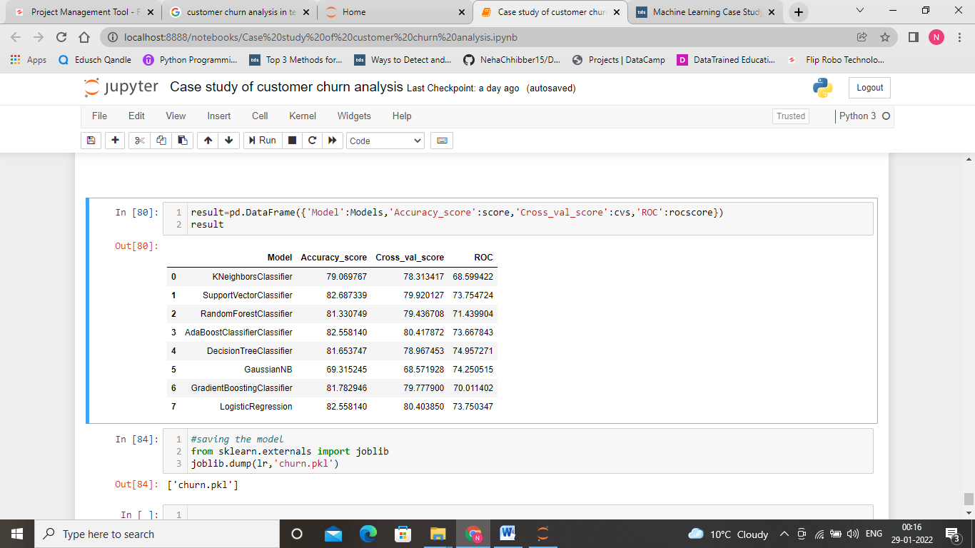

**Saving Model**

Now, let us save logistic Regression as the final model.

